Contacts:       Cheryl Sorensen – [crs149@pitt.edu](mailto:crs149@pitt.edu) – 412-648-8574

Professor Sue Skledar – [sjs15@pitt.edu](mailto:sjs15@pitt.edu) – 412-648-1504

Marcia Borrelli – NOTARY – [borrelli@pitt.edu](mailto:borrelli@pitt.edu) – 412-648-1120

PA State Board of Pharmacy – [st-pharmacy@pa.gov](mailto:st-pharmacy@pa.gov) – 717-783-7156

Supplies needed: computer, printer, scanner, checklist, debit or credit card, patience

NOTE: You will not be able to pay your fees by cash, check, money order, or wire transfer

**Part One: Child Abuse CE**

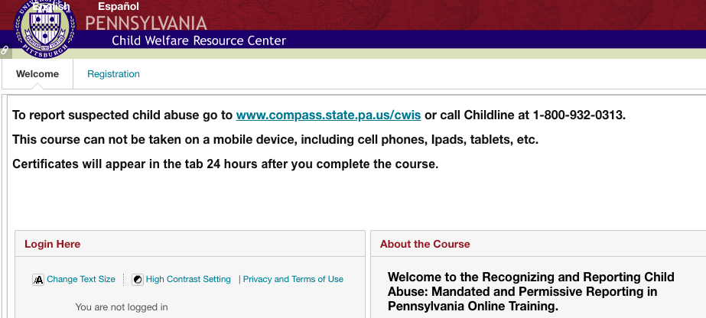Step 1: Go to <http://www.reportabusepa.pitt.edu/> and Click “Don’t Have an Account? Click Here.” or If you see the following page you came to the right place:

**IF YOU HAVE ALREADY CREATED AN ACCOUNT PREVIOUSLY**: Skip to Step 3.

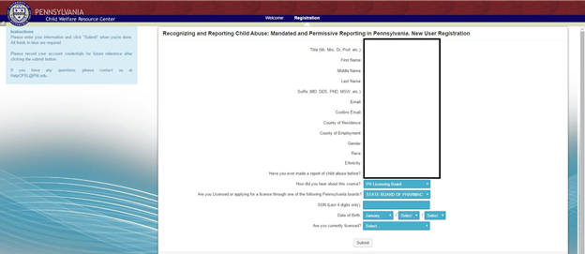Step 2: Complete the form that pops up and click “Submit”, and a **login ID and password** will be provided to you. You will receive the information in an email as well, but be sure to save the information.

Step 3: Return to the login screen and login using your provided username and password. If you forgot your username, please contact the Child Welfare Support Center directly at 877-343-0494 for assistance.

Step 4: You may click on the link “Recognizing and Reporting Child Abuse.”  Please note: The course used Adobe. You do not have to complete the course in one sitting.

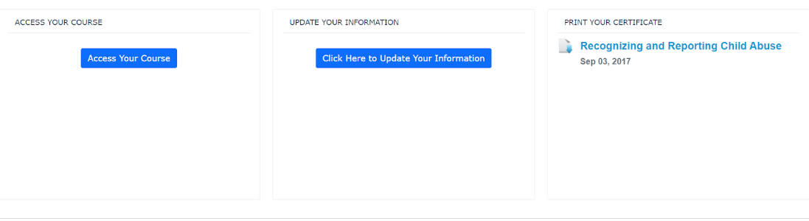**IF YOU HAVE COMPLETED THE COURSE PREVIOUSLY**:  Click on “Register Again” on the left side under ACCESS YOUR COURSE. If needed update your personal information on the next page and click save at the bottom of the page. Return to the Dashboard and now click on “ACCESS YOUR COURSE” under the “ACCESS YOUR COURSE” section.

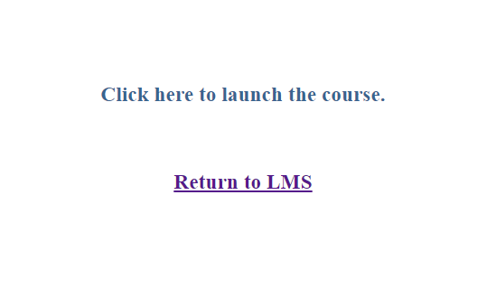Step 5: A new page will load with two options. Click on “Click here to launch the course.”

Step 6: Complete the course and **PRINT** your **certificate**. The data should automatically be provided to the State Board of Pharmacy approximately 2 weeks after completion of the course and your record should be updated.

**Part Two: National Practitioner Data Bank Self Query Report**

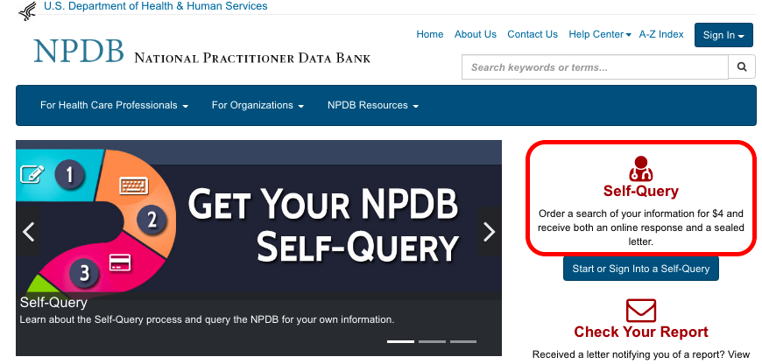Step 1: Go to <https://www.npdb.hrsa.gov/> and Click “Self Query”.

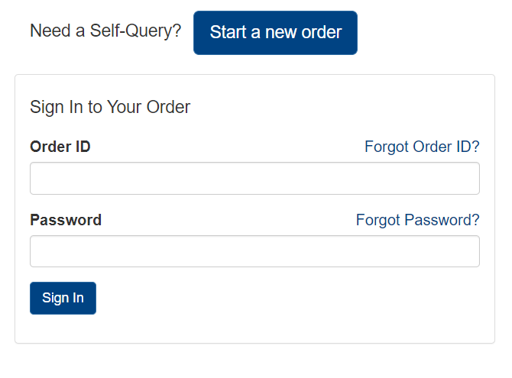Step 2: Click “Start a New Order”. Accept the terms.

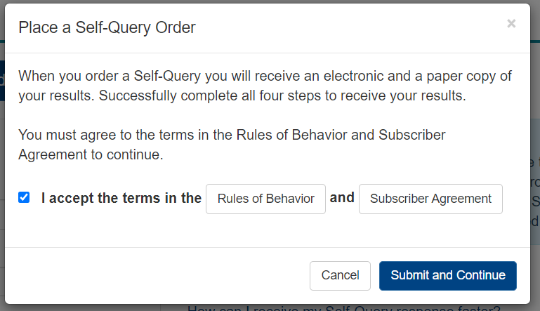Step 3: Read and click the checkbox that you accept the terms. Click “Submit and Continue.”

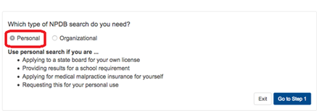Step 4: Choose “Personal” and click “Go to Step 1”.

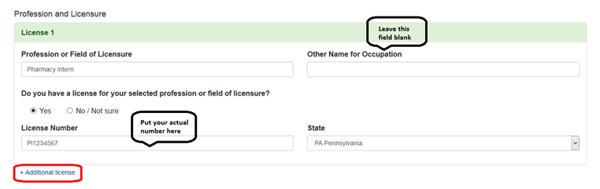Step 5: Enter your personal information and then fill out the Profession and Licensure box as indicated below. If you have any additional Pharmacy Intern licenses, add them by clicking “+ Additional license” and repeating the process.

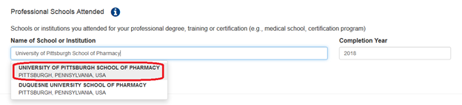Step 6: Under Name of School or Institution, begin typing “University of Pittsburgh School of Pharmacy” (it will begin to auto-populate). Click on the choice when it appears. Type “2021” under Completion Year.

Step 7: Enter your SSN (Social Security Number) or ITIN (Individual Taxpayer Identification Number) in the next box. If you have identification numbers for NPI (National Provider Identifier), DEA (Drug Enforcement Agency), FEIN (Federal Employer Identification Number), and/or UPIN (Unique Physician Identification Number), check the box and provide the information.

Step 8: Type in your email and create a password. When ready, click “Go to Step 2.”

Step 9: Enter your payment information. Click “Go to Step 3.”

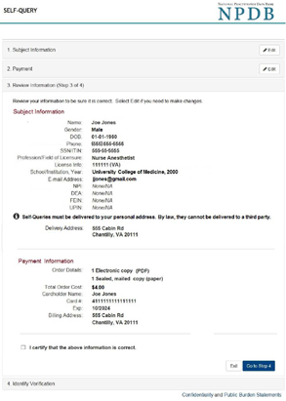Step 10: Review your information. Click the checkbox that certifies your information is correct. Click “Go to Step 4”.

Step 11: Now the NPDB will attempt to verify your identity. **It is recommended you chose the online process.**

In order to do the online process, your credit must be unlocked.

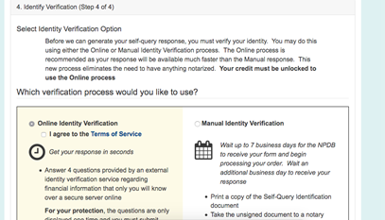NOTE: The online verification process will ask you to answer questions that only you would know about yourself. This includes, but is not limited to, bank name and number of your primary checking account; current or former addresses; names of members of your household with which you reside(d); information about student loans, car loans, and home equity or mortgages; and high school or college names.  If you are unsure of an answer, you may want to have your phone ready to contact someone (e.g. parent/guardian, spouse) who might be able to help you answer this information. If you answer wrong you will have to go through the manual process!!!

Step 11.5 (for online verification): Answer the four questions. Click “Submit Answers” when you feel confident you have answered the identity questions correctly.

Step 11.5 (for manual verification): If you chose the manual process, it will take at least 7 business days and you will need to: 1) print and bring an unsigned copy of your NPDB document to a notary public along with a government-issued form of identification and then 2) send the notarized copy to the NPDB for processing.

NOTE: Ms. Marcia Borrelli is a notary public for licensure paperwork. You can schedule an appointment with her via phone or email. YOU MUST WAIT and complete the form in her presence.

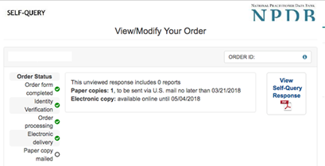Step 12: Click “View Self Query Response” to download your NPDB Self Query Report. You need this so that you can upload it on your Pharmacist License Application.

Step 13: Sign out when completed.

**Part Three: PA ePatch (Criminal History Check)**

For every state you listed on your Pharmacist License and Authorization to Administer Injectables Applications, you will need to obtain a criminal history check.

IF YOUR ADDRESS IN PALS IS PENNSYLVANIA AND ARE A PENNSYLVANIA RESIDENT, the PA ePatch CHRC will cover your state of residence (PA). You can choose to obtain a FBI IdHS for the remaining states other than your state of residence.

IF YOUR ADDRESS IN PALS IS NOT THE STATE OF PENNSYLVANIA, the PA SBOP will expect a state criminal history record check (CHRC) from your state of residence.  The checklist and application states, “For individuals living, working, or completing training/studies outside of Pennsylvania during the past ten (10) years, in lieu of obtaining individual state background checks, you may elect to provide BOTH a state CHRC from the state in which you currently reside, AND your FBI Identity History Summary Check, available at <https://www.fbi.gov/services/cjis/identity-history-summary-checks>.”  For example, if you are a resident of NY and you put a NY address in PALS for your Pharmacist application, the PA SBOP will expect to see a CHRC for NY.  In this example, the FBI check will not cover the state of residence (NY) but will cover any other state in which the applicant has lived, worked or completed training/studies (such as PA) in the last 10 years.

NOTE: Please refer to the checklist for the URLs or directions on how to obtain the background check. When asked the reason for the PA background check, choose “Other”. If there is an option on other states to choose “Licensure”, use that. For the FBI IdHS, choose “Personal Review” as the reason.

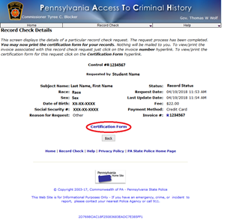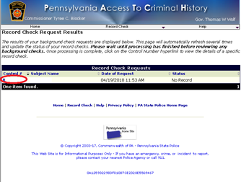Step 2: When you get the results of your record, download electronic copies of each background check.  For PA, click on the blue hyperlink for the Control number and then click “Certification Form” on the next page. This will produce a certificate to upload.

Step 3: Upload (or scan and upload) the background checks to **all** parts of the State Board applications.

**Part Four: Online Application for PA Pharmacist Licensure**

Step 1: Access the application by navigating to PALS - <https://www.pals.pa.gov>

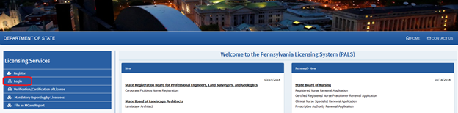Step 2: Click “Login” to access your PALS account. If you don’t remember your login information and aren’t able to reset it yourself online, you will need to call the PA SBOP. You will need to create a new password after you login. I would recommend keeping these in a safe location so you can log in and check the status of your application.

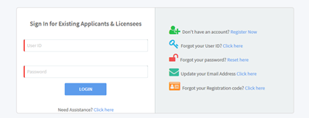PALS Login:

Step 3: Verify your personal information, paying special attention to your name and the address where you want your license to be assigned. If you need to change your name, you will need to contact the PA SBOP directly and supply one of the following acceptable legal documents:  marriage license, divorce decree or court order.

Click “Save Changes” to update your profile information. Click the checkbox to which account these changes should apply and then click “Submit”.

After you have verified/updated your information, you will be prompted to log back in using your new password. Your verified/updated information will now be grayed out and you will not be able to change it.

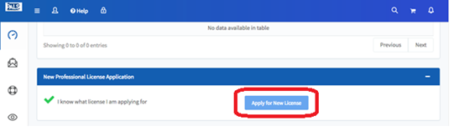Step 4: Scroll all the way down to the bottom of the page and under New Professional License Application, click “Apply for New License”

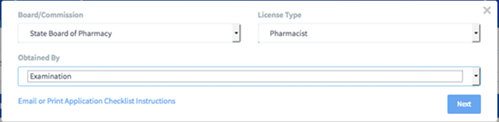Step 5: Fill out the drop down bars as indicated below: Board/Commission – State Board of Pharmacy, License Type - Pharmacist, Obtained by - Examination. Click “Next” in the bottom right of that same screen.

Step 6: The top of the page will contain details about the rules for applying for licensure. Review your information and then scroll down to the Education box.

Step 7: Under the Education with Dates Attended box, fill out the information as indicated below: College, University or Professional School - **University of Pittsburgh**, Address – **3501 Terrace St, Pittsburgh, PA 15261**, Dates Attended From – **8/28/2017**, Dates Attended To – **05/01/2021**, Major Course of Study and Degree Awarded - **PharmD**, Graduation Date – **05/01/2021**.

(it is VERY important you list **graduation date as  5/1/21**- this is the date the school will put on our diplomas despite our ceremony being on 4/30/2021)

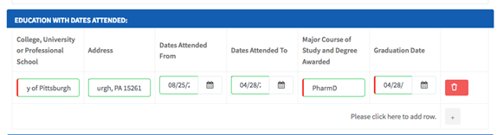**\*\*Do not list your BSPS if you earned one\*\***

Step 8: Answer the questions below.

* For PA Pharmacy Intern Registration, you will need to enter your PA intern license number; the number is listed in the section above this one on the application.
* For intern hours outside of your academic program, this pertains to **paid internship hours, not rotations**. Answer “Yes” if you earned any intern hours outside of this Commonwealth, unless they were earned through an international experience.
* 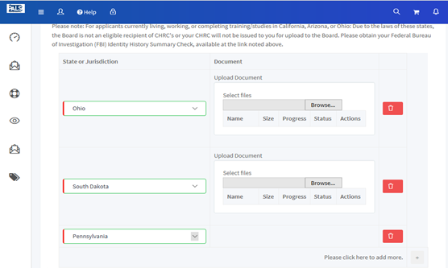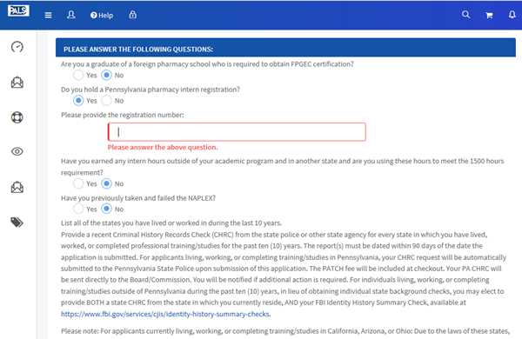For states where you have lived or worked in the last 10 years, **rotations count**! List the state(s); you can use one FBI background to cover all states outside of PA unless you are not a PA resident.  (See Part 3 for more information.) You must upload your CHRC(s) before you can advance and submit your application.

Step 9: Answer the legal questions, then click on the check box that you verify the statements are true and correct and that you agree to the terms. Sign with your full legal name.  You may also add a delegate to receive emails about your application status at this point.

NOTE: If you answered “Yes” to any of the legal questions, you will need to submit additional documentation. Print the next page that comes up and follow the directions carefully. This page **must** accompany that information so the Board can track it with your application.

If you answered “yes” to the first legal question on the PA Pharmacist application concerning holding a license in any health field, this message pertains to you:

If you were required to obtain a Pharmacy Intern license for work or rotation(s) outside of PA, the PA SBOP will require a license verification.  Please contact the state board in which you hold a license to request a verification be sent board to board. The PA SBOP is unable to accept a verification that is not sent board to board.  There may be a cost associated with a license verification request. For instance, in Alaska, there is a form under CBPL Quick Links (Request License Verification) and the cost is $20.

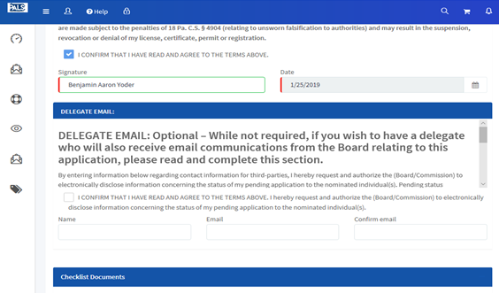**NOTE**:  If your license is from Colorado, Maine, New Hampshire, New York, North Carolina, and/or Virginia, the PA SBOP is not eligible to receive license verifications and will perform a manual search.

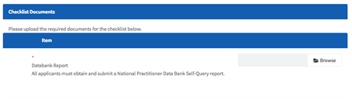Step 10: At the bottom of the page, you will need to upload your National Practitioner Data Bank Self-Query Report using the “Browse” button.

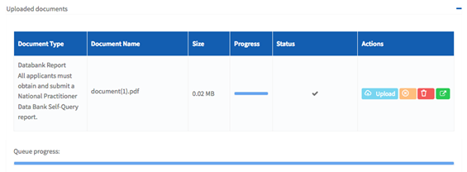Locate the saved file and click “Upload” to proceed. When the document is uploaded, you will see a checkmark in the Status box.

If you uploaded the wrong file, click “Remove” (the trash can icon) and re-do the process. When you are satisfied with your upload, click “Continue” to move to the next page.

Step 11: Review your information before finalizing your application and making payment. Click “Add to Cart” at the bottom of the screen.

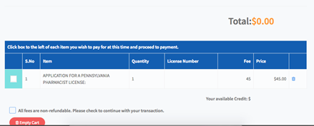Step 12: On the next screen click the checkbox beside your application. Your total will update from $0 to $45. Check the box agreeing that the fees are non-refundable and then “Proceed to Payment” will appear for you to move to the next page.

Your receipt will be emailed to you, but feel free to add a second email if you would like a payment confirmation to be emailed. Save records of everything.

Step 13: After your payment is processed, you will be redirected to your checklist. Download the “Certificate of Pharmacy Education and Pharmacy Intern Experience”. The form will be pre-populated with your contact information from the application. This is what you will give to the school, and the school will submit to the Board within 30 days of graduation.

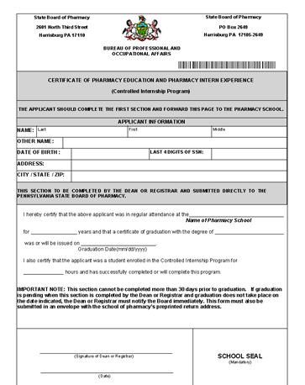The form will look like this: **(This is an example! Do not use this form!!)**

NOTE:  Your form will have a barcode that is uniquely tailored to you.  Use only the form that is downloadable on your account for you.

Step 14: Click “Go to Dashboard” to return to the PALS home page.

**(OPTIONAL) Part Five: Authorization to Administer Injectables**

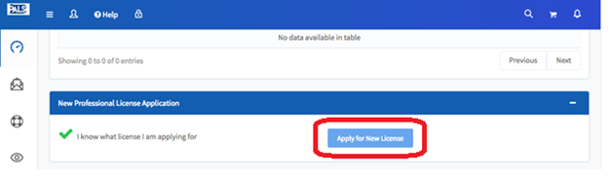Step 1: On the PALS homepage, scroll all the way down to the bottom of the page and under New Professional License Application, click “Apply for New License”

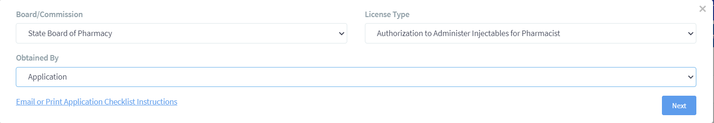Step 2: Fill out the drop down bars as indicated below: Board/Commission – State Board of Pharmacy, License Type - Authorization to Administer Injectables, Obtained by - Application. Click Next in the bottom right of that same screen to proceed.

Step 3: A new page will open details about the rules for applying for licensure. Read the messages and verify your information.

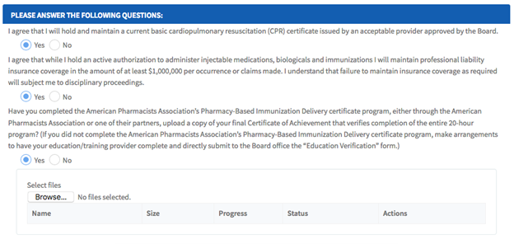Step 4: Answer the legal questions and then click “Browse” to choose the file and upload your Injectables certificate.

Locate the saved file and click “Upload” to proceed. When the document is uploaded, you will see a checkmark in the Status box. If you uploaded the wrong file, click “Remove” (the trash can icon) and re-do the process. When you are satisfied with your upload, click “Continue” to move to the next page.

Step 5: Check off on all the states you have lived or worked in. This is the same question as the previous application (Part 4, Step 8). You will need to upload your FBI background check here as well.

Step 6: Read the verification statement and click on the check box that you verify the statements are true and correct and that you agree to the terms. Please sign with your full legal name again.

Step 7: Download your CPR e-certificate from Castlebranch or scan a **copy** of your **CPR card (front and back)**. Upload a copy of your CPR card using the “Browse” button.

Locate the saved file and click “Upload” to proceed. When the document is uploaded, you will see a checkmark in the Status box.

If you uploaded the wrong file, click “Remove” (the trash can icon) and re-do the process. When you are satisfied with your upload, click “Continue” to move to the next page.

Step 8: Click “Add to Cart.”

Step 9: On the next screen click the checkbox beside your application. Your total will update from $0 to $30. Check the box agreeing that the fees are non-refundable and then “Proceed to Payment” will appear for you to move to the next page.

Your receipt will be emailed to you, but feel free to add a second email if you would like a payment confirmation to be emailed. Save records of everything.

Step 10: After your payment is processed, you will be redirected to your checklist. Download the “Certificate of Education and Training for the Authorization to Administer Injectable Medications, Biologicals and Immunizations” **only if you didn’t complete the APhA training provided by the School of Pharmacy**. Make arrangements to have your education/training provider complete the form and submit it directly to the PA SBOP.

NOTE: The form will be pre-populated with your contact information from the application. This is what you will give to the school and the school will submit to the Board within 30 days of graduation.

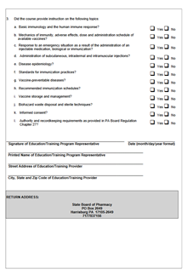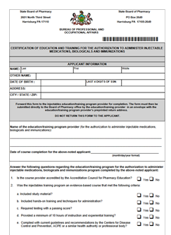The form will look like this: **(This is an example!! Do not use this form!!)**

Step 12: Click “Go to Dashboard” and log out of PALS.