**NABP Registration**

Instructions for registering with the NABP.  Some things to keep in mind as you prepare to register:

* Be sure that your name matches on the SBOP and NABP websites as well as on your acceptable primary and secondary forms of identification to sit for the exams.  See the attached NABP 2021 Bulletin for more information on name matching guidelines (pages 9-10).
* There are discounts available for members of the armed forces and their spouses. See the attached NABP 2021 Bulletin for more information (pages 22-23).
* If you would like to request testing accommodations under the ADA, there is an additional form that must be completed and uploaded to the NABP. In states in which the NABP confirms eligibility (e.g. Florida), the accommodation form and documentation must be uploaded during the application process.  The testing accommodation request will be evaluated by the appropriate board of pharmacy first, and then forwarded to the NABP for review. See the attached NABP 2021 Bulletin for more information (page 7).

**Part One: NAPLEX/MPJE Registration**

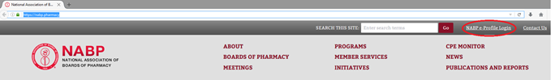Step 1: Go to<https://nabp.pharmacy/>. Click “NABP eProfile Login” in the upper right corner.

Step 2: Click “Individual or Business Customers”.

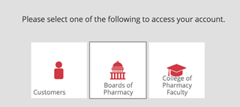

Step 3: You will have previously created an NABP e-profile. Please use the username and login from this account as you should only have one NABP e-profile for your entire career. If you forget your login information, use the “Forgot Password?” option to obtain your credentials. Your username is likely your Pitt email address.

NOTE: You may be asked to reset your password to comply with new password standards. If you do, you will receive an email verification code to reset your password.

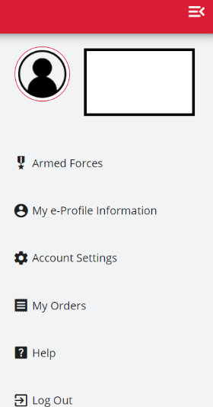Step 4: After successfully logging in, click on the 3 vertical lines on the top right of the page followed by My e-Profile and then Update My e-Profile to complete the eProfile review. **Verify your legal name to ensure it matches** **exactly as it appears on the two forms of identification you will present at the test center, including middle initials, middle names, or suffixes.** If there is not an exact match, you will not be able to take your test and you will not be reimbursed for any fees paid.

NOTE: Name changes can take up to 5 days to process.

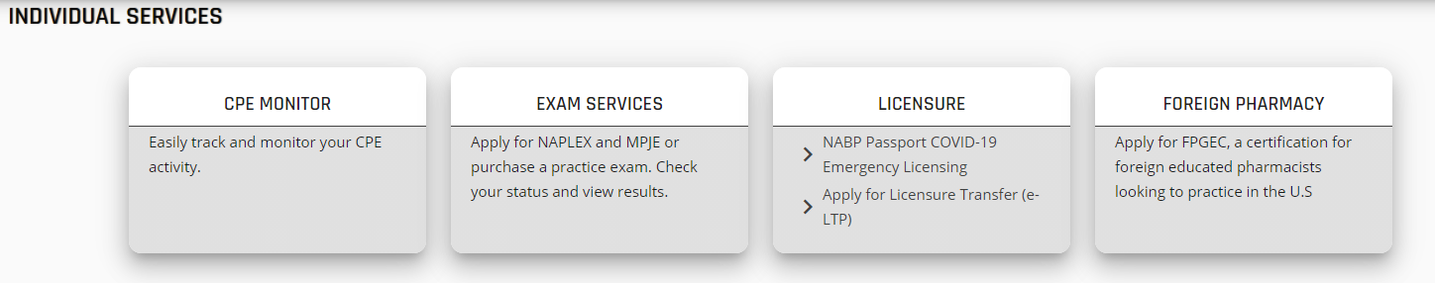Step 5:  When finished, go back to the Home Page and click on Exam Services to begin the registration process for the NAPLEX and/or MPJE.

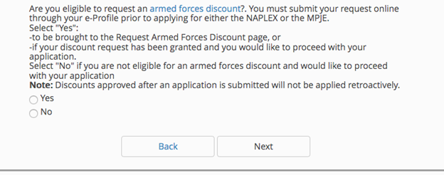Select Yes or No for the armed forces discount eligibility and click Next.

NOTE: If you are eligible for the armed forces discount, you must select this prior to applying for the exam(s). Eligibility is not available retroactively.

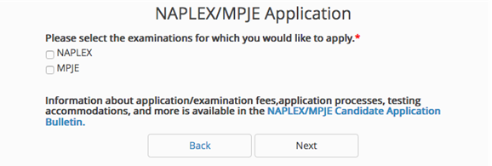Step 6: Choose which exam(s) you wish to take and then click Next.

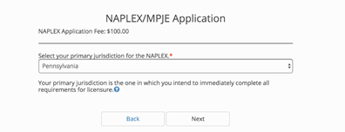Step 7: Choose your primary jurisdiction for NAPLEX then click Next.

NOTE: There is an additional $85 non-refundable fee for candidates who select Colorado, Kentucky, Maine, Michigan, Nebraska, Oregon, Rhode Island, and/or Utah as their primary state of eligibility as NABP confirms eligibility to test for those jurisdictions.

Then choose your MJPE jurisdiction(s). NOTE: For each MPJE jurisdiction, you will pay a separate deposit. Click Next.

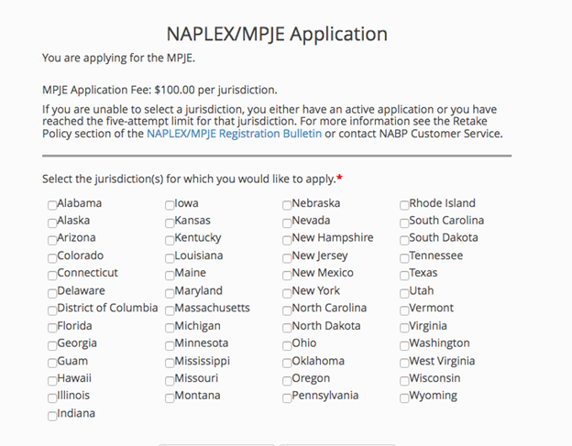MPJE Jurisdiction(s):

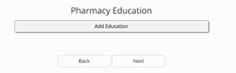Step 8: Under “Pharmacy Education”, click Add Education.

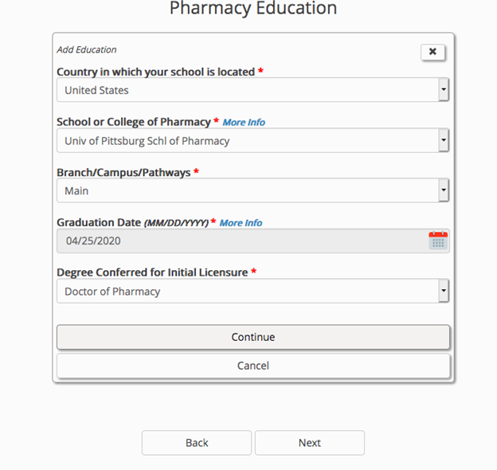Click on “United States” to get started and then enter the Education information as below and then click Continue. For the graduation date, enter **05/01/2021**.

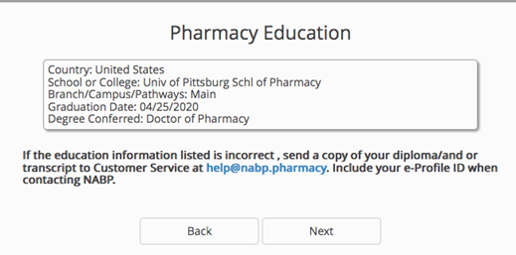Step 9: Review your Education details and click Save. Once submitted, you must submit a copy of your diploma and/or transcript to Customer Service to change your education information, so fill this information out carefully. After you verify your information, click Next.

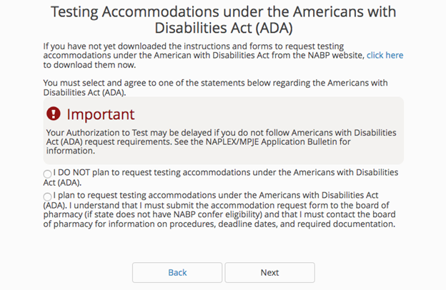Step 10: Under Testing Accommodations, choose the radio button that corresponds to your testing needs. Click Next.

NOTE: If you plan to request accommodations, there is a form that needs to be completed and paperwork to be submitted. You can access the form here -<https://nabp.pharmacy/e-profile-customer-forms/ada-request-form/>.

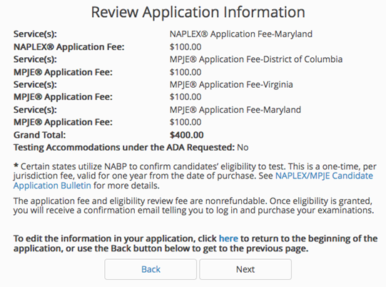Step 11: Review applicant information. Click Next if everything is correct.

Step 12: Enter your legal name under contact information and secondary address (if needed). Click Next.

Step 13: Review your billing information. Click Submit. PRINT your confirmation on the next page.

Step 14: Your information will be sent to Pearson who handles the scheduling of the exams. You will have to wait until the State Board authorizes you to test and Pearson emails you an ATT (authorization to test) letter. Until you receive that ATT, wait at this step.

Fees:

NAPLEX: $575

MPJE: $250 (each jurisdiction)

NAPLEX/MPJE Bulletin 2021 –

<https://nabp.pharmacy/wp-content/uploads/2019/03/NAPLEX-MPJE-Bulletin-2021.pdf>

**Part Two: Register with Pearson VUE after you receive your ATT Letter**

After the Board of Pharmacy determines candidates’ eligibility to take the examination, it will notify NABP. Candidates who have registered for the NAPLEX and/or MPJE will receive an ATT letter or letter from Pearson VUE. The ATT letter includes eligibility dates during which you may take the examination, instructions for scheduling your testing appointment, and other important information. The ATT letter is typically valid for 1 year.

Candidates should make sure all information in their ATT letter is correct. Check to make sure your name on the ATT letter exactly matches the two forms of identification you will bring to check into the testing center. Middle initial versus middle name is okay, but suffixes and inclusion/exclusion of middle name must match.

Step 1: Check to ensure your ATT letter name is satisfactory as described above

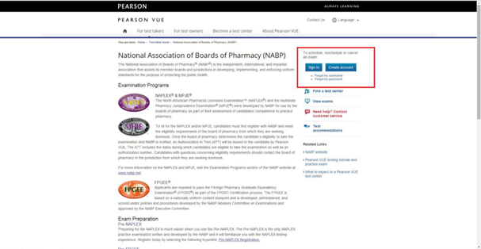Step 2: Go to<http://www.pearsonvue.com/nabp/>.

Step 3: Follow the instructions to set up an account and schedule your exam. This is when you can purchase a NAPLEX score transfer (or up to 90 days after the exam). Information on NAPLEX Score Transfer can be found in the NAPLEX/MPJE Bulletin on pages 6-7, 17-18, 20-21.

Step 4: Study, study, study.

Step 5: Take the exam, pass, and become a full-fledged pharmacist.

NOTE: All pharmacist licenses expire on September 30 of even­ numbered years and will need to be renewed.