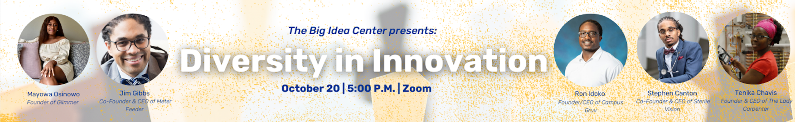

**Diversity in Innovation – Tues, Oct. 20 | 5 PM | Zoom**

New for 2020! Is it harder to be a Black entrepreneur? What unique challenges do minority entrepreneurs face when getting their startup off the ground? Please join us for our Diversity in Innovation Panel as a panel of Black founders and CEOs shed light on the racial divide within the startup and entrepreneurial community as well as how they’ve been able to forge their own path as a minority entrepreneur. This unique panel is a partnership between Pitt’s Big Idea Center, the Institute for Entrepreneurial Excellence, Pitt’s Office of Diversity and Inclusion, and Pittsburgh’s Black Tech Nation.

Registration is required in order to receive the link and password for the event. [Register here.](https://go.innovation.pitt.edu/diversity_panel)

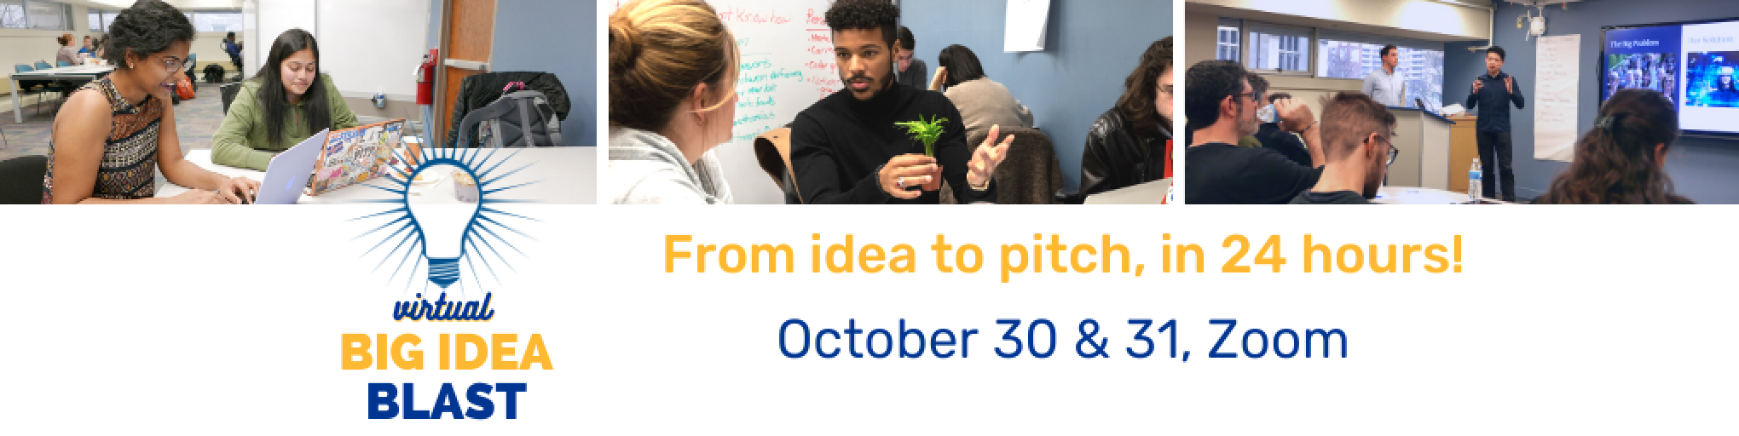

**Virtual Big Idea Blast – Fri, Oct. 30 & Sat, Oct. 31 | Zoom**

In this 24-hour, virtual weekend workshop, students will have a chance to work on their ideas and win unique prizes including a fast-pass to the final round of the Randall Family Big Idea Competition! Our event will begin on Friday with a group meetup and informational session followed by our first round of presentations. On Saturday, finalists will have a chance to schedule coaching sessions with our staff of entrepreneurs in residence. The day will conclude with final presentations and a live q-and-a with our guest judges.

This unique opportunity is a chance to participate in concentrated mentorship and coaching on your Big Idea! Take a shot at presenting your project prior to entering our spring Randall Family Big Idea Competition.

Registration is required in order to participate in this event. [Register here.](https://go.innovation.pitt.edu/blast)

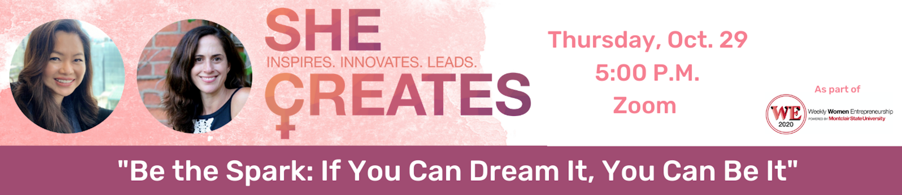

**She Creates – Thurs, Oct. 29 | 5 PM | Zoom**

Theme: “Be the Spark: If You Can Dream It, You Can Be It”

What pressures do women entrepreneurs face in the business world and how do they navigate through those challenges? How can women shape their own mold for success when it comes to building and running a startup? Please join us for She Creates as we showcase women who hold leadership roles both within the Pittsburgh entrepreneurial community and beyond and discuss the difficulties of being a woman entrepreneur.” The She Creates panel is a partnership between the Big Idea Center, Women In Bio-Pittsburgh, PNC, numo, and CMU Project Olympus.

Registration is required in order to receive the link and password for the event. [Register here.](https://go.innovation.pitt.edu/shecreates)

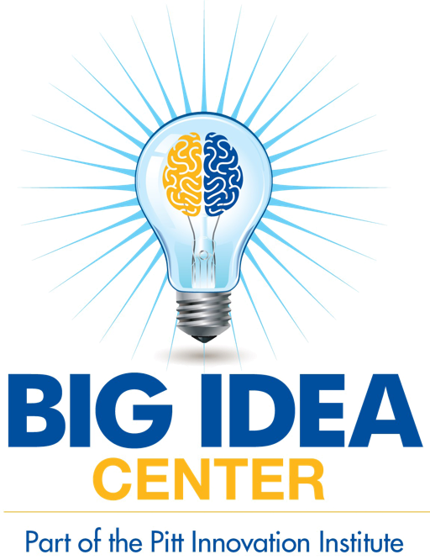

Stay up-to-date on all things student innovation & entrepreneurship here at Pitt! Follow the Big Idea Center on [Instagram](https://www.instagram.com/pittbigidea/), [Twitter](https://twitter.com/pittbigidea), & [Facebook](https://www.facebook.com/pittbigidea) at @pittbigidea

Learn more about the Big Idea Center by checking out their website [here](https://www.innovation.pitt.edu/).