**University of Pittsburgh**

**School of Pharmacy Clothing Sale**

Presented by Lambda Kappa Sigma

Dear Students, Parents, Faculty and Staff,

It is time for the fall LKS / School of Pharmacy clothing sale! As one of our fundraisers, the sisters of Lambda Kappa Sigma provide you with the opportunity to purchase University of Pittsburgh School of Pharmacy merchandise. In order to ensure that all clothing will be ready in time for the end of the semester, all order forms must be received **no later than Friday, October 9th.** The hooded sweatshirts, crewnecks, quarter zips, and polo shirts are embroidered. Attached is an order form that can be emailed to either fundraising co-chair (emails below).

Please include payment when placing your order—cash, checks, or venmo (preferred) will be accepted. **Make checks payable to Lambda Kappa Sigma**. **Venmo account is @PittLKS** (please list the items you wish to order in the Venmo description)**.** Please highlight the size(s) and quantity for each selected item.We are unable to offer shipping to your home; students can pick up the items in student services on the second floor in the pharmacy school once the items arrive. Email completed order forms to Bryn or Danielle. If you have any questions, please contact **either fundraising co-chair: Bryn O’Mara (**[**beo18@pitt.edu**](mailto:beo18@pitt.edu)**) or Danielle DiGiorgio (**[**dmd131@pitt.edu**](mailto:dmd131@pitt.edu)**).**

**Checks can be mailed to the following:**

Bryn O'Mara

2553 Allequippa St

Pittsburgh, PA 15213

Thank you for your support! -LKS

**Disclaimer: The Pitt Shop prohibits returns/exchanges, as these are all custom items. Similar items are available in the store for comparing sizes, if necessary.

1 2 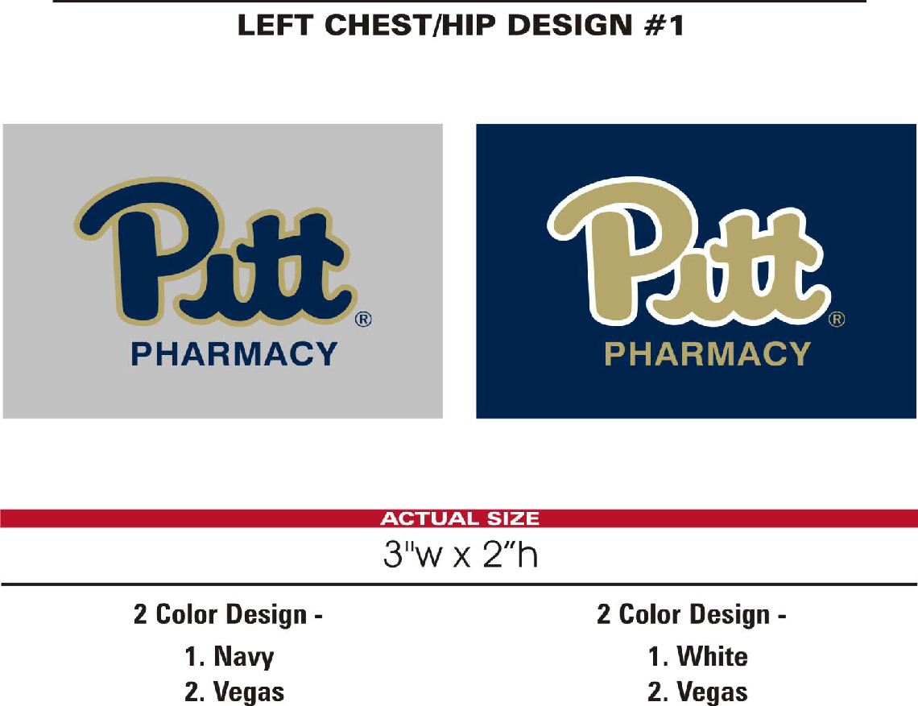

|  |
| --- |
| Logo designs: 1. Hoodie/ Crew neck/ Quarter zip/ Sweatpants/Polo 2. T-Shirts  **Note: All items will be in retro colors, Logo 2 will say “School of Pharmacy” instead of “Panthers” |

****CLOTHING ITEMS ARE NOW IN **RETRO** **COLORS**\*\*\*\*

School of Pharmacy Clothing Sale Order Form

Please submit **no later than Friday, October 9th**

Student Name:                                           _________________________________

Student Class: P1   P2   P3    P4

Phone Number:                    ______ __E-mail:                  _____________ _______

Total Amount Due:                                Please Select:  Cash      Check      Venmo**___**

|  |  |  |  |  |  |
| --- | --- | --- | --- | --- | --- |
| **Item** | **Price** | **Color (circle)** | **Size (circle)** | **Quantity** | **Total $** |
| Hooded Sweatshirt | $48 | Heather Gray | S M L XL |  |  |
| Crew neck Sweatshirt  *will say “School of Pharmacy” under Pitt | $45 | Heather Gray | S M L XL |  |  |
| 1/4-zip Sweatshirt, collared with logo in upper left | $48 | Charcoal Gray | **Unisex**  S M L XL |  |  |
| Golf Polo Shirt: “PITT Pharmacy” in upper left | $48 | Royal Blue | Men: S -> XL  W: XS -> XL |  |  |
| Sweatpants, elastic waist & non-elastic bottoms: left leg near thigh | $38 | Heather Gray | S M L  XL |  |  |
| Short sleeve T-shirt (Pitt script logo in athletic gold & white)* | $17 | Royal Blue | S M L XL 2XL |  |  |
| Long sleeve T-shirt (Pitt script logo in athletic gold & white)* | $21 | Royal Blue | S M L XL 2XL |  |  |
| TOTAL |  |  |  |  | $ |

*For short and long-sleeve T-shirts: In order for the vendor to screenprint the t-shirts, we must have a minimum order of 48 shirts (any combination of short/long sleeves). Please indicate on your order form if you would like a T-shirt. When all order forms are submitted by Oct. 9, we will notify you if we reached the minimum and are able to order them!