2020 Fleece Sale Order Form
Presented by:
Student Society of Health-System Pharmacists

Men’s Fleece  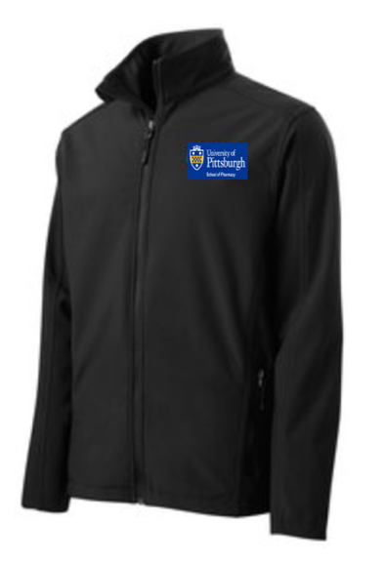 | Emblem   | Women’s Fleece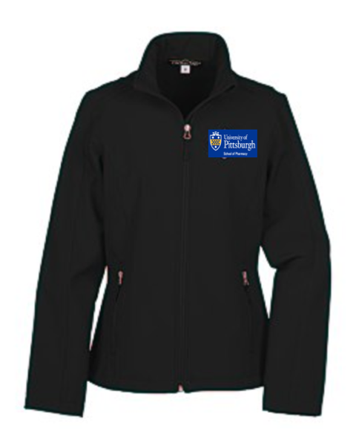

Description:
- This black soft shell jacket with 100% microfleece lining is the perfect professional jacket, embellished with the new Pitt Pharmacy logo. It features a chin guard, front zippered pockets, and both a wind- and water-resistant exterior to keep you warm and dry at school or work!

Prices and Sizes:
- Men’s Fleece (Sizes: S-5XL, LT-5XLT): $35 each
- Women’s Fleece (Sizes: XS-3XL): $35 each

Payment:
- Order your fleece(s) through the payment page found in the link below!
- https://pittpharmacy.wufoo.com/forms/q10g16ui0khp8mw/

The order form will be open until 11:59 PM on Wednesday, September 30, 2020

