CPNP 2020 Virtual Conference Registration Instructions

- go to https://cpnp.org/

For CPNP non-members:
- Create an account by clicking “sign in” and then “create new account”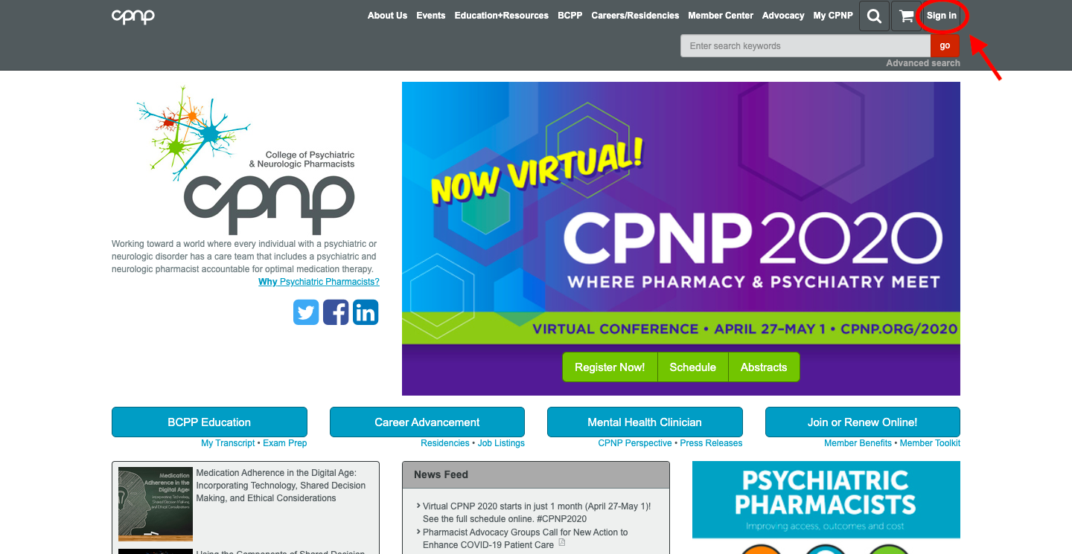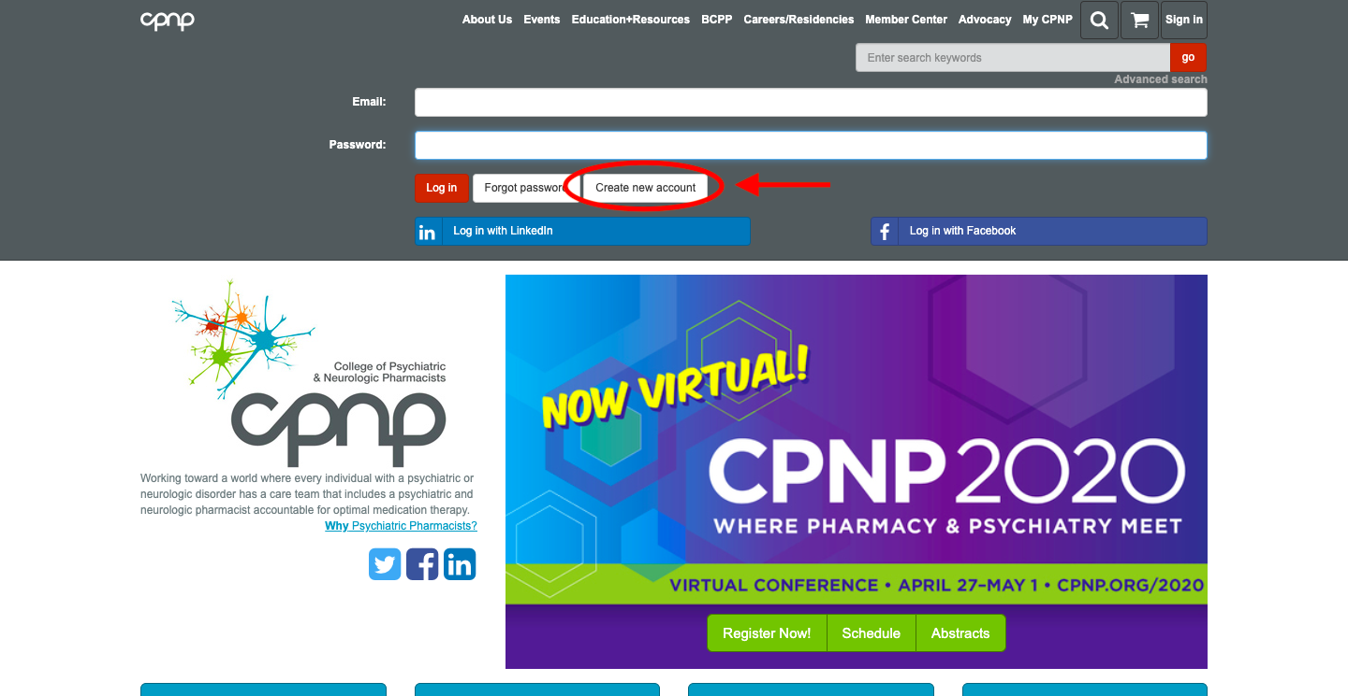
- Fill in your information for the create new account page as directed.
  - use your school email to sign up
  - Ignore all the boxes that aren’t required, or put N/A if option
  - For “organization name” put “The University of Pittsburgh, School of Pharmacy”
  - If it asks for a sponsor later on, put “Tanya Fabian, e-mail fabiant@upmc.edu.”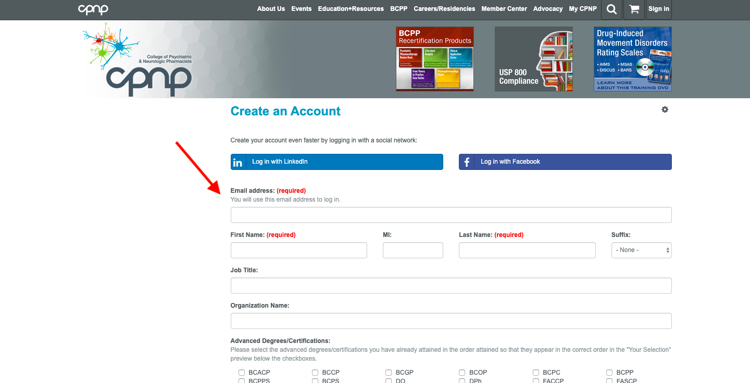
- Finish creating account. You will eventually receive an email from cpnppitt@gmail.com confirming your account was created successfully. You CANNOT register for the conference until you’ve received this email confirmation.
- Proceed to below step 2 once email confirmation is received.

For CPNP Members and Non-members who have an account made already:
2) click on “Register now!” on home page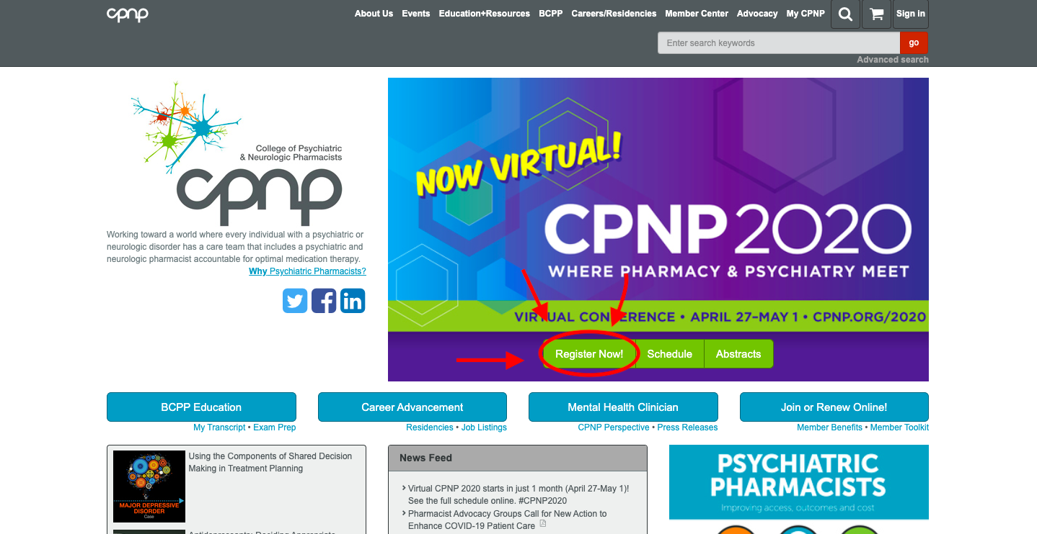

3) Then login to your account by clicking “login” on the registration page. 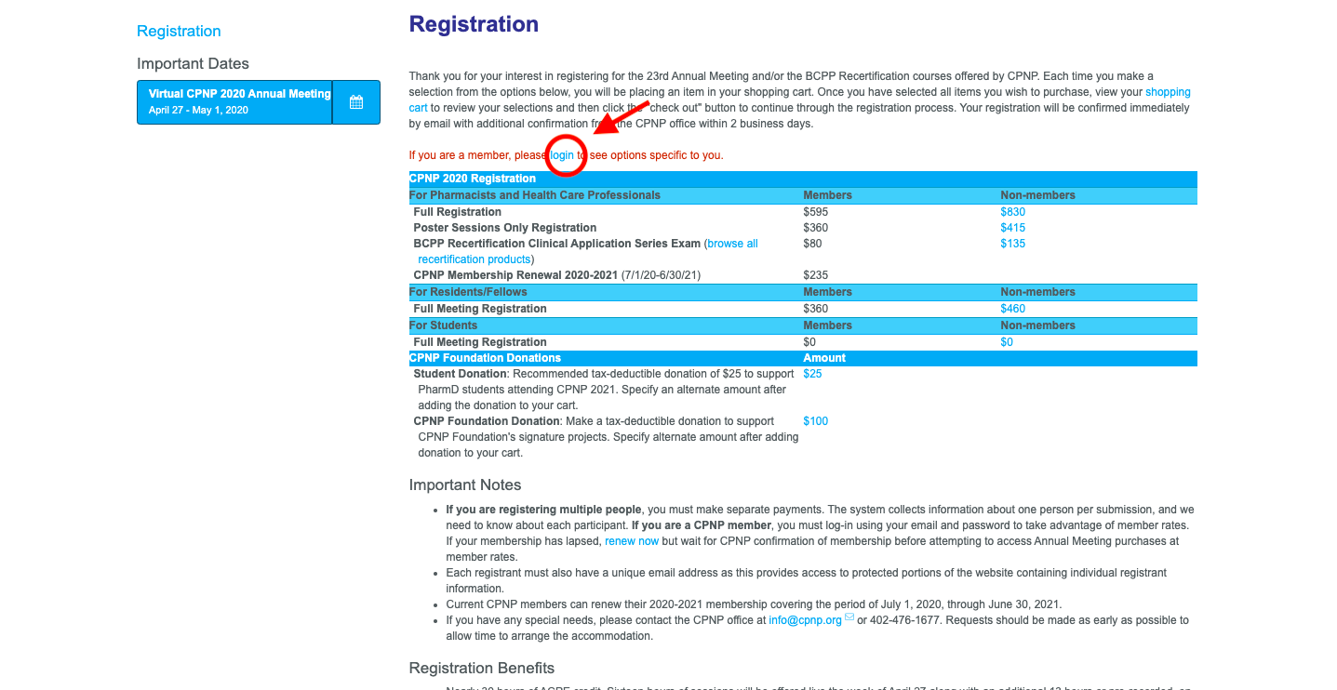
4) You’ll be prompted to login to your existing account prior to registering. 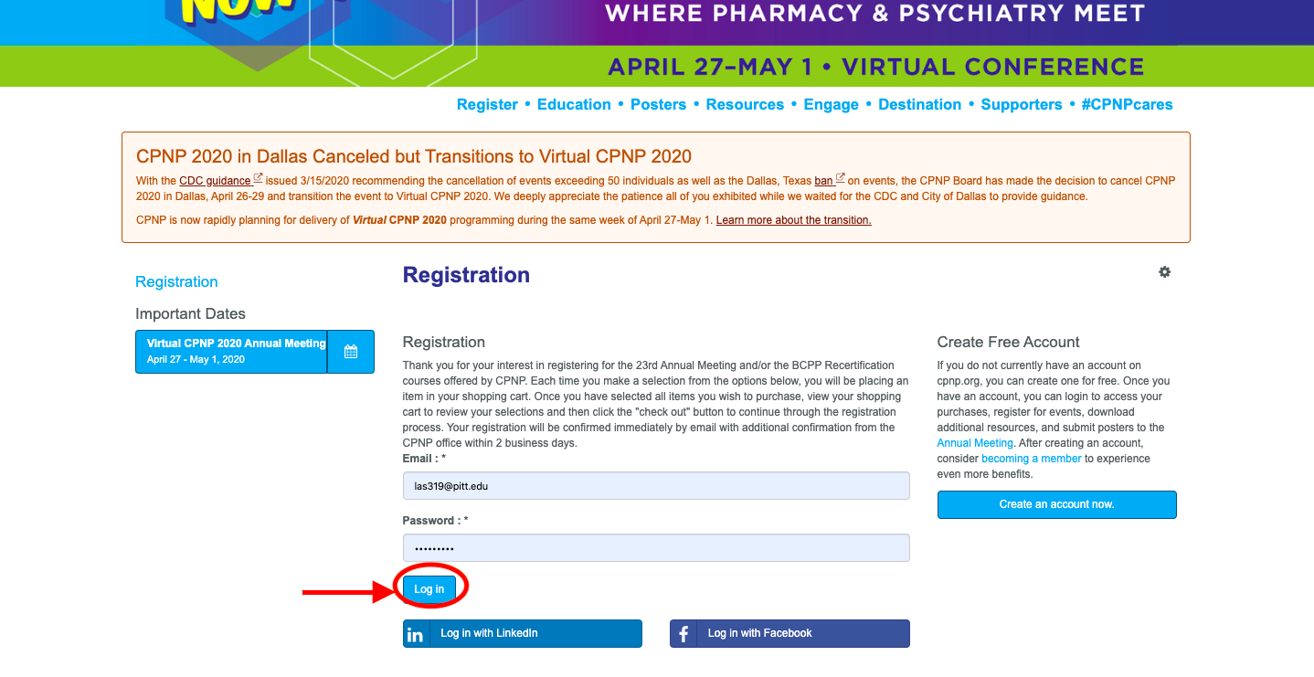
5) Upon logging in, you’ll be redirected back to the registration page. From here, click on the “$0” under the “For Students” section. Members click on the $0 under “members:” and non-members click on the $0 under “non-members”. Notice that both prices are the same, but it’s important to click under the correct category.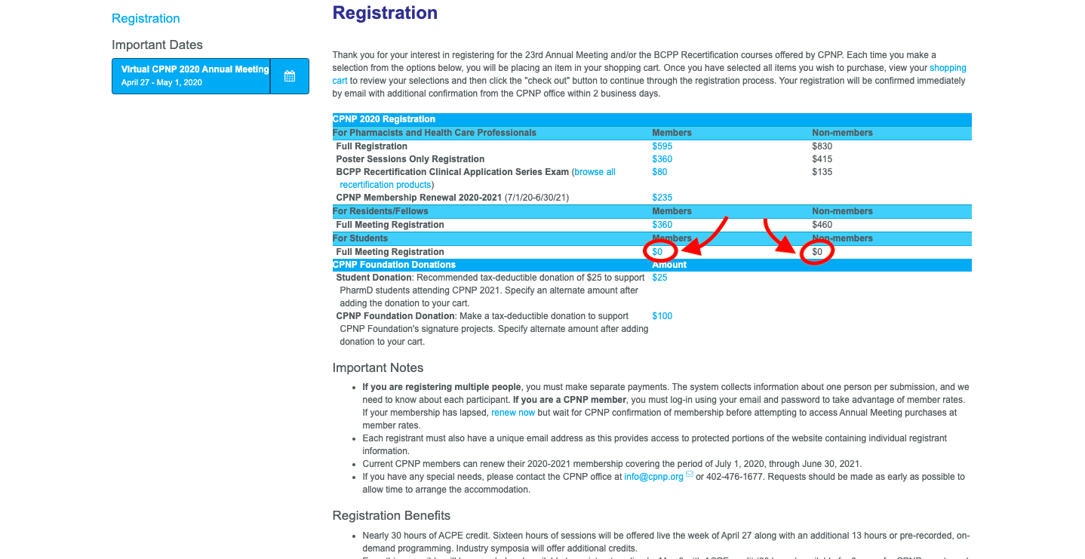
6) After you click the $0, a new hyperlink will appear that says “view cart”. Click it. 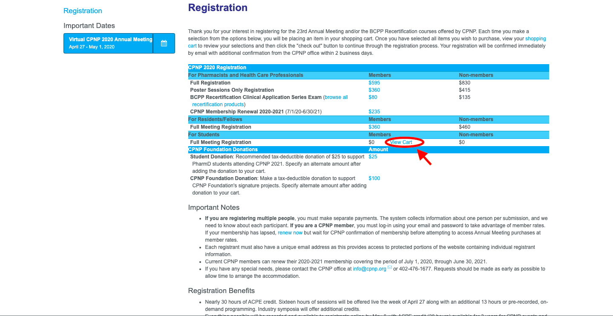
7) From there, you’ll be prompted to check out. Information regarding the conference and conference materials will be sent to your email in the future. Thanks for registering!!

If you have any questions, text me at (717)575-3227 or email at las319@pitt.edu

Thanks,
Lauren

