Registering and Creating Requests for myClinicalExchange

Dear myClinicalExchange Student,

Welcome to the myClinicalExchange program (mCE). We are making your clinical rotations more organized, efficient, and easy to manage! The directions provided in this letter are intended for students who will submit their own placement request directly to Kaiser Permanente Mid- Atlantic States (Kaiser Permanente will be referred to as “the Hospital” throughout this document and myClinicalExchange communication). If your University Coordinators arranges and manages your rotation, please disregard these instructions and contact your University Coordinator for further direction.

This informational letter is divided into several parts:

Step 1: Registration

Step 2: Log In & Navigation

Step 3: Submitting your Request

Step 4: Payment

Step 5: Completing Compliance

Troubleshooting Tips

You may press and hold the CTRL key on your keyboard and then click on one of the topics above and you will be directed to the appropriate section of this informational letter.

We wish you a successful year and trust you will find mCE a simple and helpful tool in your academic career!

Sincerely,

mCE Team

Step 1: Registration

If you already have an account with myClinicalExchange, you can use your existing account, there is no need to re- register. If not, please proceed:

Please navigate to <https://www.myclinicalexchange.com/MainPage.aspx> by either following this link or copy/pasting it into your web browser.

We recommend using the following internet browsers for the optimal use of myClinicalExchange.

* Google Chrome
* Firefox
* Safari

1. In the upper right corner of the homepage, click the **Students** button and select **Registration** from the drop-down menu.



You will be navigated to a page where you can choose from the two options below.



1. Click on the **New Account** (the red box) option. You will be directed to Step 1 of 3.

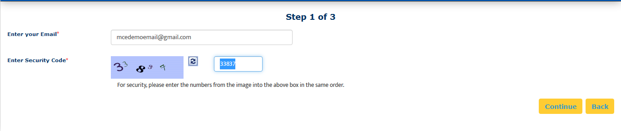

1. Enter your school-issued email (the green box above).
   1. You must use a proper e-mail address as the system will send you a validation code in the next step. You may use a personal e-mail address if your University does not issue University-based e-mail addresses.
2. Enter the security code numbers in the blank box (the orange box above).
   1. If you cannot read the security code, click the “refresh” icon  to see a new set of numbers. There will be NO letters, just numbers.
3. Click **Continue** and you will be navigated to Step 2 of 3.
4. A validation code with be sent to your email from [do-not-reply@myclinicalexchange.com](mailto:do-not-reply@myclinicalexchange.com). Please check your inbox for that validation code. If you do not see your validation code in your email, please click on **Resend Validation code**.
5. Enter the validation code (blue box below).
6. Enter the security code (yellow box below).

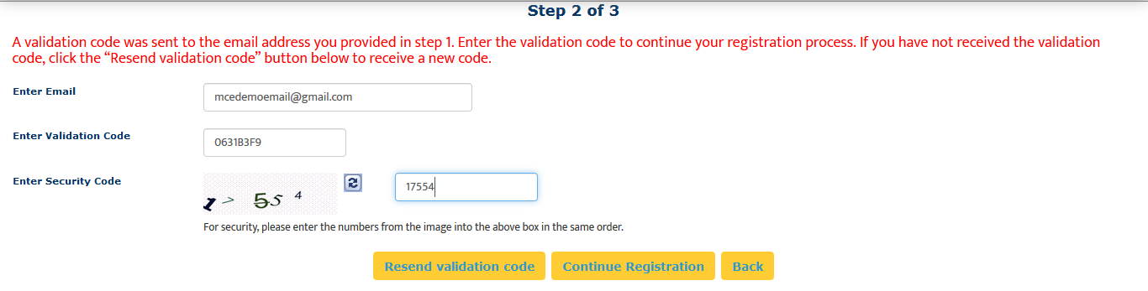

1. Click on **Continue Registration**. You will be directed to Step 3 of 3 where you input your personal information.

Please note that a red asterisk next to a box means that information is required to proceed in mCE.

This next area can be broken down into four sections; Personal Information, School Enrollment Details, Emergency Contact Person, and Login Details.

Personal Information: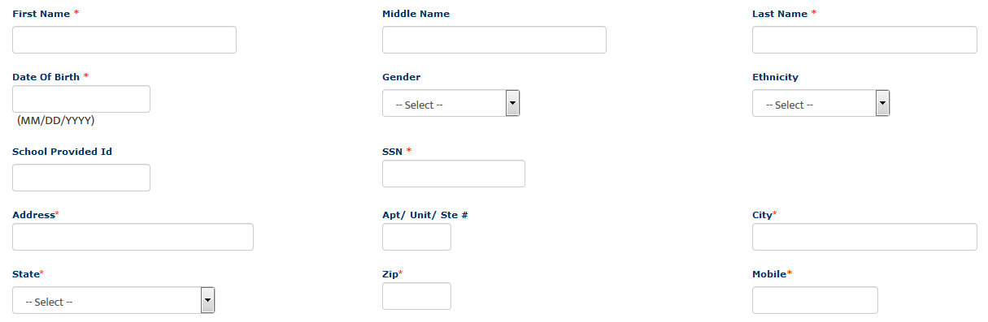

The following information is required on this page:

**First Name**: Your legal first name.

**Last Name**: Your legal last name.

**Date of Birth**: Your date of birth (no one under the age of 13 is allowed to register).

**SSN**: Your full social security number with no dashes.

**Address**: Your physical place of residence.

**City**: The city in which you reside.

**State**: The state in which you reside.

**Zip**: Enter the zip code associated to your address.

**Mobile**: The best contact number you can be reached at.

Please note that myClinicalExchange does not share or sell your information.

School Enrollment Details:

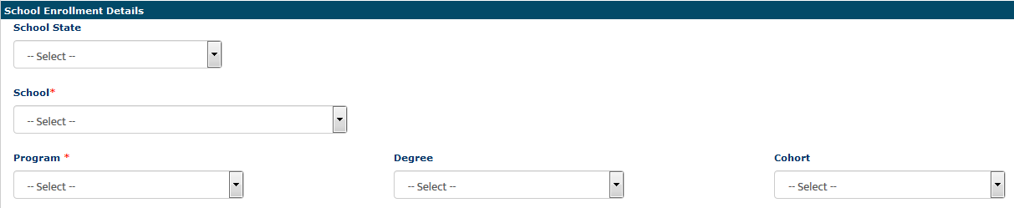

**School State:** Please select the state your Academic Institution is located in. This is not a required area; however, it does assist in the data filtering process.

**School**: Select the name of your Academic Institution.

If you **do not** see the name of your Academic Institution, please select **Not Yet Listed** and enter the information the system prompts you to input.

Please carefully check. Our team will need to create the Academic Institution profile and we will be emailing you for further details. This could potentially take 3 to 5 business days.

**Program**: Select the program you are enrolled under at your Academic Institution.

If you **do not** see the name of your program, please select **Not Yet Listed** and enter the information the system prompts you to input.

Please carefully check. Our team will need to create the Program profile and we will be emailing you for further details. This could potentially take 3 to 5 business days.

Emergency Contact Person:



**Name**: Enter your Emergency Contact’s first and last name.

**Relationship**: Enter their relationship to you.

**Phone**: The best contact number they can be reached at.

Login Details:



**Login ID**: The email you entered at the beginning of this process will populate in this area.

**Password**: Enter in your password.

**Confirm Password**: Re-enter your password.

At the end of these four parts, you will see the image below.



In order to proceed forward, please check the box to agree to the [Privacy and Terms](https://register.myclinicalexchange.com/Privacy.pdf) and [Web App Usage Terms of Service.](https://register.myclinicalexchange.com/AppUsageTerms.pdf)

11.) Click on **Complete Registration**. You will see a confirmation page indicating that your account has been created UNLESS you indicated that your University/Program was “Not Yet Listed”. If your University/Program was not listed, please give our team 3-5 business days to create your University/Program and associate your account. At that point, you will receive a notification to log in.

12.) Click **Continue** to be navigated to the Student Login Page.

Step 2: Log In & Navigation

1. On the login page, enter the email and password you created in the *Login Details* area. Click **Login**.
   1. If you don’t remember your password, use the “Forgot Password?” link to have your password emailed to you.
2. Please read the disclosure and click **Accept**.
3. You will be prompted to create Security Questions. Once you’ve entered that information, click **Save & Continue**.

To better understand how to use mCE, please check out our FAQ’s  at the top-right of the page or our YouTube channel at <https://www.youtube.com/user/myClinicalExchange>.

On your homepage, you will see several important things you will need to access and understand.

1. The top left corner will indicate your Account Status is “Paid” or “Unpaid” (purple box below).
   1. You do NOT need a payment against your account in order to submit a Request for a placement. However, IF your placement request is Approved, Kaiser MAS will pay for your account.
   2. PLEASE **DO NOT** pay for your mCE account on your own!
2. You will see four tabs of information under your Account Status.

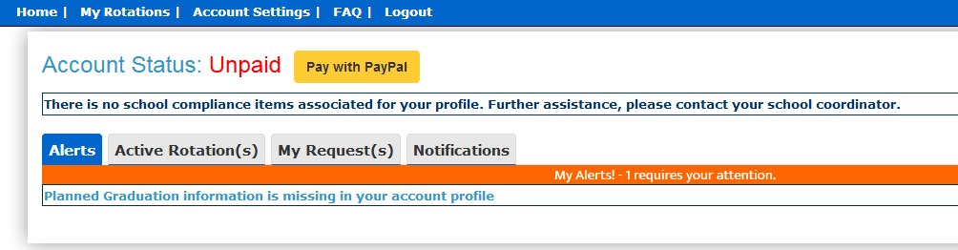

* 1. **Alerts**
     1. The *My Alerts!* center lists all the items that are pending completion. If an item is connected to a specific rotation, the Rotation Number is listed first followed by the item pending completion.
  2. **Active Rotation(s)** 
     1. Any rotations that are approved and you have been scheduled for are listed in your Rotation area. If you click the Rotation Number, you will be directed to a more detailed page regarding that specific rotation.

If you do not have any **Alerts** or **Active Rotations**, that means you have not yet been scheduled:

1. You may not have submitted a placement Request yet. See the next section “Submitting Your Request” for information on how to submit your own Request.
2. The Request may still be “Pending”. Check the “My Request(s)” tab for a status update.
   1. **My Request(s)** 
      1. You will need to submit your own Request for a placement. Request(s) you’ve submitted will be listed here along with the “Status” of the Request.
   2. **Notifications**
      1. Any messages sent to you from your Academic Institution, Hospital Coordinator, and any auto notifications from mCE will be listed here.

Step 3: Submitting your Request

1. Click on the “My Request(s)” tab
2. At the top right, click the yellow **New Request** button.

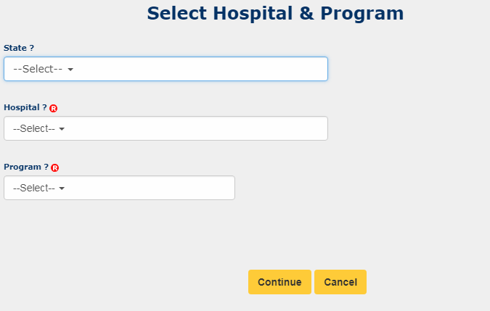

1. From the “State” drop-down, select the State where the **Hospital** (Kaiser Permanente) is located. For Kaiser Permanente Mid- Atlantic States, you should choose “Maryland” regardless of whether you want to rotate in MD, DC or VA.
   1. This is not a required field but it will help you narrow your search a bit.
2. From the “Hospital” drop-down, select the name of the Hospital where you want to rotate (Kaiser Permanente)
3. From the “Program” drop-down, select the type of rotation you are seeking. (PharmD)
   1. If you do NOT see your correct Program, please stop and email [support@myclinicalexchange](mailto:support@myclinicalexchange) for assistance. The program you select here will dictate the type of requirements you receive later on. If you are seeking a Pharmacy placement and you select ‘Physical Therapy’, you’ll receive the Physical Therapy onboarding requirements.
4. The Request process is broken into three steps: School Info, Schedule Preferences, and Checklist.
   1. Only items marked with the A close up of a sign

      Description generated with very high confidenceare required. You may leave the other fields blank if you would like.

School Info:

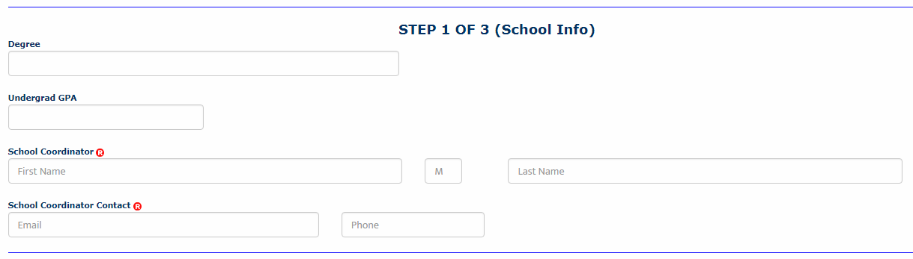

**Degree:** Enter the Degree you are seeking at your Academic Institution.

**Undergrad GPA:** Enter your GPA score from your Undergrad enrollment

**School Coordinator:** Enter their first and last name

**School Coordinator Contact:** Enter their email address and phone number (this will help your Hospital know who to contact with any questions about your rotation)

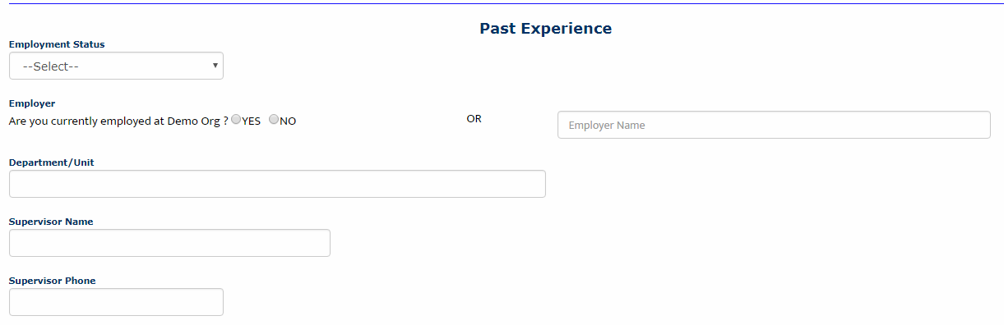

**Employment Status:** From the drop-down, select “Part Time”, “Full Time” or “Unemployed”.  ***\*This section pertains ONLY to employment at Kaiser MAS. DO NOT FILL OUT if NOT employed at Kaiser MAS, just skip the section.\****

1. If you select “Part Time” or “Full Time”, you will need to provide information in the following fields.
2. If you select “Unemployed”, you will not need to provide further information in this section.

**Employer:** Are you currently employed at the Hospital where you are submitting your rotation request? Select “Yes” or “No”.

1. If you select “Yes”, please provide more information in the fields below.
2. If you select “No”, please provide the name of the Hospital where you currently are employed in the text box on the right and then continue with the fields below.

**Department/Unit:** If you currently employed at a Hospital, enter the Department and/or Unit where you work.

**Supervisor Name:** Enter the name of your Supervisor at the Hospital where you are employed.

**Supervisor Phone:** Enter the phone number of your Supervisor at the Hospital where you are employed.

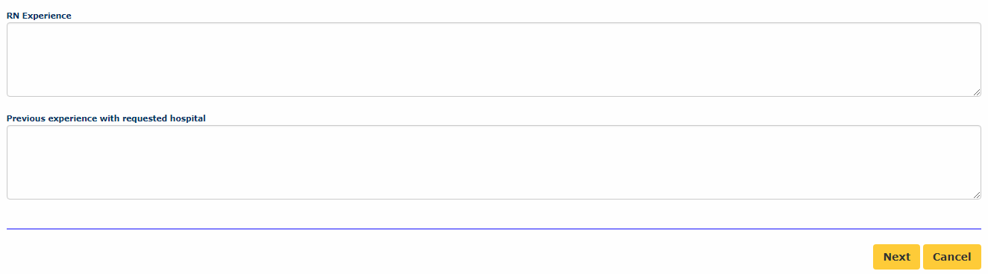

**RN Experience:** Enter any pertinent details for the Hospital Coordinator to consider as they review your placement request.

**Previous experience with requested hospital:** Enter any information that may assist the Hospital Coordinator in approving/declining your placement request.

1. Click **Next** to move on to step 2 of 3

Schedule Preferences:

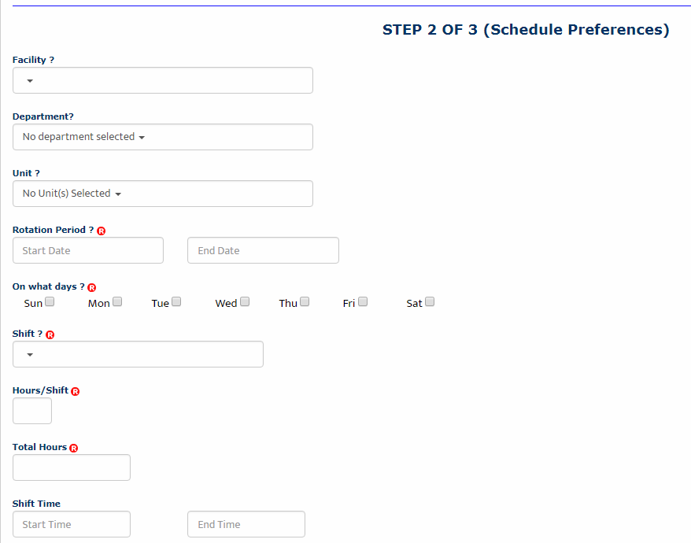

**Facility**: This field does not apply to Kaiser Permanente- leave blank.

**Department**: Select from the drop-down. This is usually the type or clinical area where you’d like your rotation to occur.

**Unit**: This is a sub-menu of the above “Department”. Select accordingly. This “Unit” will list the locations where the type (department) of rotation you are requesting is currently offered. Please select the location closest to your desired location. Note that depending on preceptor and site availability, you may not receive assignment at the particular site that you request, but this will give Dr. Fink a reference point to be able to get you as close as possible to your ideal location.

**Rotation Period**: Enter the exact dates that your school will use for the Start and End Date of your rotation. Enter the format at mm/dd/yyyy OR use the drop-down calendar to make your selection.

**On what days**: Check mark one or more days. If your schedule will vary each week, select any day you *might* be on rotation. (i.e. Monday through Fridays [no weekends] or Sunday through Saturday etc.)

**Shift**: Select from the drop-down

**Hours/Shift**: Enter the number of hours you expect your shift to be each day. (i.e. 8-hour shifts, 10-hour shifts etc.) If your shift time may vary, please enter your expected average. Shift hours may not exceed 24.

**Total Hours**: Enter the total number of hours you must log by the end of rotation. This could be your course requirement, OR the total hours based of your schedule set above. (i.e. If you work 40 hours a week for 8 weeks, your total hours are 320 hours [40 x 8 =320])

**Shift Time:** If you know the start and end time of your shift, please enter in this format HH:MM XM

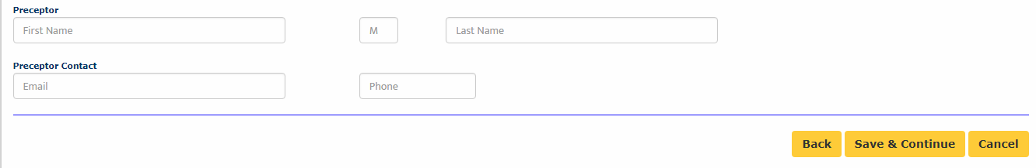

**Preceptor**: This field does not apply to Kaiser Permanente- leave blank.

**Preceptor Contact**: This field does not apply to Kaiser Permanente- leave blank.

1. Click **Save & Continue** to go to step 3 of 3.

Checklist:

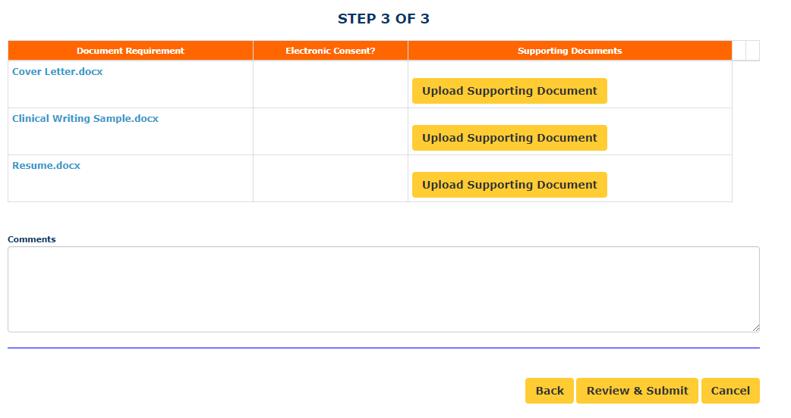

1. In the first column are your Compliance documents. To open these documents, you will want to click on the name of the document. The document will then be downloaded to your computer, and you will be able to open the document and see what the requirement is that will need to be uploaded.
2. The second column, labeled “Upload Supporting Document”, is where you upload each document against the correct requirement.
3. If you had made a mistake and uploaded the incorrect document, there is a trashcan that appears next to the document name. If you click on that icon, you can delete the document and upload the correct one.

ALL documents must be uploaded **in order for the request to be submitted.**

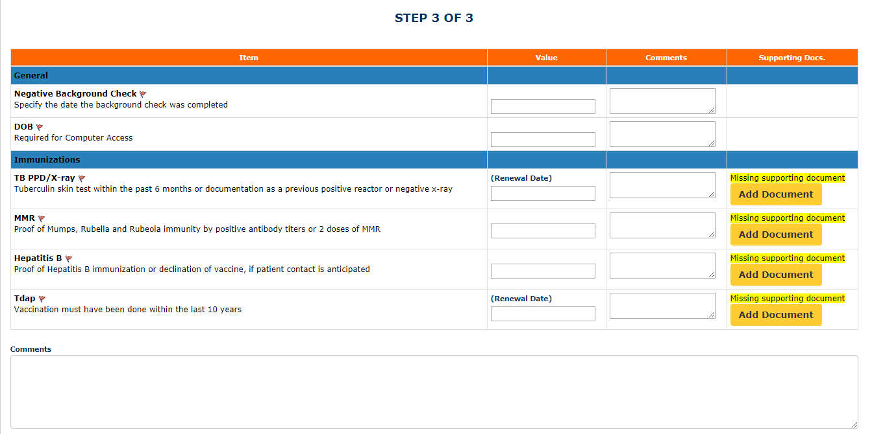

**Comments**: Enter any final comments or notes to the Hospital Coordinator (Dr. Fink) at the bottom of the checklist. ***Also, please list your department preferences in order of desirability in the comments box. For example, if you really want Pediatrics as your #1 choice, you would also like Advanced Community and would accept Nephrology if neither Pediatrics or Advanced Community are available, list in the order of preference: 1.) Pediatrics, 2.) Advanced Community, 3.) Nephrology***

1. Click **Review & Submit**
2. You will be asked to review all the fields you’ve just filled in once more. Make any necessary changes and then click **Submit Application**.
3. The Hospital will receive your rotation request and review it.
   1. If they decline your request, you will receive an auto-email from the platform letting you know. At that time, you do not need to do anything further.
   2. If they approve your request, you will receive a notification from mCE prompting you to log in and provide payment. PLEASE DISREGARD!! Kaiser MAS will pay for your account. Please see the next section on “Payment” for more information.

Step 4: Payment

Kaiser MAS will be paying for your account. DO NOT pay for your account on your own or you will need to contact [support@myclinicalexchange.com](mailto:support@myclinicalexchange.com) for a refund.

When Kaiser MAS has paid for your account, you’ll see it marked at the top of your Home Page (see green outline below). DO NOT click the **Extend Subscription** button or you will be prompted for payment.

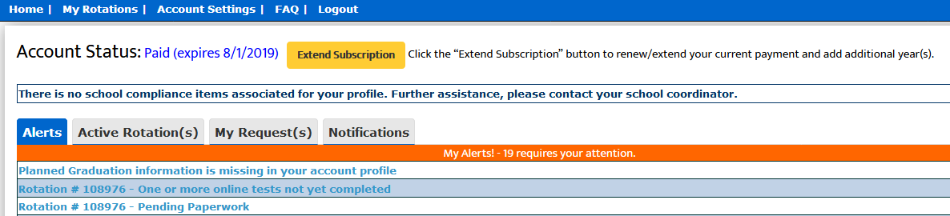

Once a payment has been applied to your account, move on to the next section Step 5: Completing Compliance.

Step 5: Completing Compliance

To better understand how to use mCE, please check out our FAQ’s  at the top-right of the page or our YouTube channel at <https://www.youtube.com/user/myClinicalExchange>.

1. On your Home Page, click on your **Alerts** tab.
   1. The *My Alerts!* center lists all the items that are pending completion. If an item is connected to a specific rotation, the Rotation Number is listed first followed by the item pending completion. Click on the blue alert to be navigated to the requirements for completion.

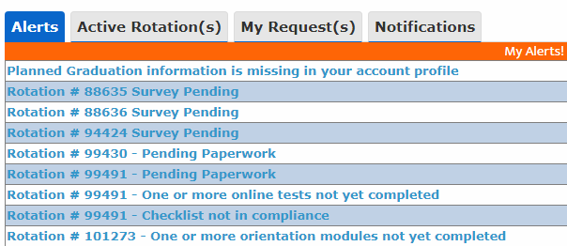

1. Click your **Active Rotation(s)** tab to see more details about the rotation you have been approved for.

If you do not have any **Alerts** or **Active Rotations** that means you have not yet been scheduled:

1. You may not have submitted a placement Request yet. See the above section “Submitting Your Request” for information on how to submit your own Request.
2. The Request may still be “Pending”. Check the “My Request(s)” tab for a status update.

Troubleshooting Tips

* **What email should I use?**
  + If your Academic Institution issues email addresses, please use the one they gave you. This is a more secure email server than Google, Yahoo, Hotmail, etc. If your Academic Institution did not provide you an email address, a Google, Yahoo, Hotmail, etc. email address is acceptable.
* **Why haven’t I received my validation code?**
  + It can take up to 15 minutes for the validation code to be sent to your email. If you’ve waited 15 minutes, please check your junk folder, Spam folder, or Clutter Box. The e-mail will be from [do-not-reply@myclinicalexchange.com](mailto:do-not-reply@myclinicalexchange.com). Please mark e-mails from the domain “myclinicalexchange.com” as a “Safe Sender” so that future correspondence comes immediately to your inbox. If you still have not received the email, verify the email you entered is correct.
* **Why isn’t Internet Explorer loading this website?** 
  + Are you are using Internet Explorer, v8 or lower? If so, you will either need to update Internet Explorer to v9 or higher. Alternatively, try again in Chrome, Safari or Firefox.
* **Why do I have to create Security Questions?**
  + When you create your security questions you make recovering your password much easier in the event you forget your password.
* **What do I do if I forget my login I.D.?**
  + Please reach out to your Hospital Coordinator for this information.
* **I forgot my password. How do I login?**
  + To retrieve your password, please navigate to the mCE website.
    - Click the **Student** button.
    - Click **Forgot Password?**.
    - Enter your email address and the Security Code.
    - Click **Email Password**.
    - Please check your inbox for an e-mail from [do-not-reply@myclinicalexchange.com](mailto:do-not-reply@myclinicalexchange.com) assigning you a password.
* **I paid for my account out of pocket! How do I get a refund?**
  + Please email [support@myclinicalexchange.com](mailto:support@myclinicalexchange.com) and we’ll provide a refund for you mCE account.

If you are still experiencing issues, you can e-mail [support@myclinicalexchange.com](mailto:support@myclinicalexchange.com). Please provide your name, the University you attend, and a brief description of the issue you’re experiencing.