*Steps: Be Antibiotics Aware – CDC TRAIN*

1. **LINK:** [https://www.train.org/cdctrain/course/1075730/compilation](https://na01.safelinks.protection.outlook.com/?url=https%3A%2F%2Fwww.train.org%2Fcdctrain%2Fcourse%2F1075730%2Fcompilation&data=02%7C01%7Cdsk30%40pitt.edu%7C895da5f433654e7f431808d696a60fdf%7C9ef9f489e0a04eeb87cc3a526112fd0d%7C1%7C0%7C636862039332640123&sdata=Haf1V5F%2FOMBo%2BFybpZ8vJ552C6IIsgU404asx8RFW4o%3D&reserved=0)
2. **“Create an account”**
   * + Login name: Pitt username (without @pitt.edu)
     + Create a password
     + Email Address: Use your pitt email – including @pitt.edu
     + Time Zone (Eastern)
     + Zip code (personal or school)

* (2) Select a Community of Practice
  + 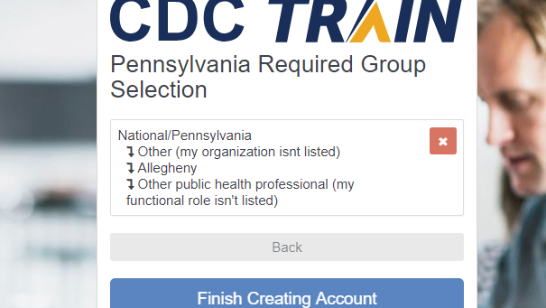**Students & Future Workforce**
  + Confirm these selections
* (3) Select a County
  + **Allegheny**
* (4) Select a Functional Role
  + **Other public health professional (my functional role isn’t listed)**
  + Confirm these selections
* (5) Select an Organization
  + **Other (my organization isn’t listed)**
  + Confirm these selections
* **(6) FINISH creating account** (NOT DONE!)
* (7) Click **+Register**
  + Go to profile

1. **“Your Profile” – You will see “!” in the categories you must fill out**
   * (8) Contact
     + Enter your phone number
     + (9) Address
       - Fill out required fields
       - (10) Organization
       - “Organization name” – **University of Pittsburgh**
       - “Department/Division” – **School of Pharmacy**
       - “Title” – **Student Pharmacist**
   * (11) Professional Role
     + (scroll down & select) – Student
   * (12) Work Settings
     + Select “Other (specify)”
     + Please enter into box “**Student**”
   * (13) CLICK SAVE! (then click Close)
   * (14) CLICK +Register
2. **Home Screen, then please click “+Register”**
   * Credit Type – it will read: Before you can register, you need to select a credit type
   * (15) Please select **NONE**
   * You are now able to access & complete all three modules!
3. **How to Successfully Complete Modules (Progress is saved if you leave early)**
   * Click module (two options should appear)
   * Select **View Course**
   * Click **Launch** 
     + Watch module
   * **Refresh** website “View Course”
     + (16) Click “**Mark Completed**”
     + (17) Click “**Take Assessment”**
       - Complete the Assessment
     + (18) Click “**Mark Completed**”

NOTES: **Navigating the Website**

1. Select **Home**

* Click “**Your Training Status**”
  + Click “**Your Current Courses**”