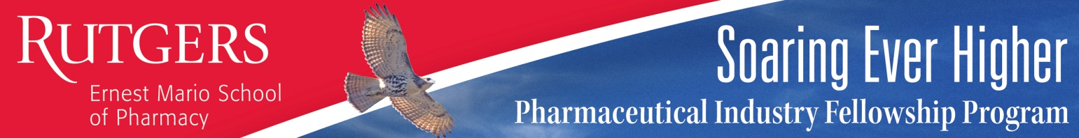

Rutgers Institute for


Rutgers Pharmaceutical Industry Fellowship
Fellowship Information Session
Presented by: Joe Kosto, PharmD, RPh: Class of 2015
September 20th 2018
12:00-1:00 PM

Salk Hall, Room 402
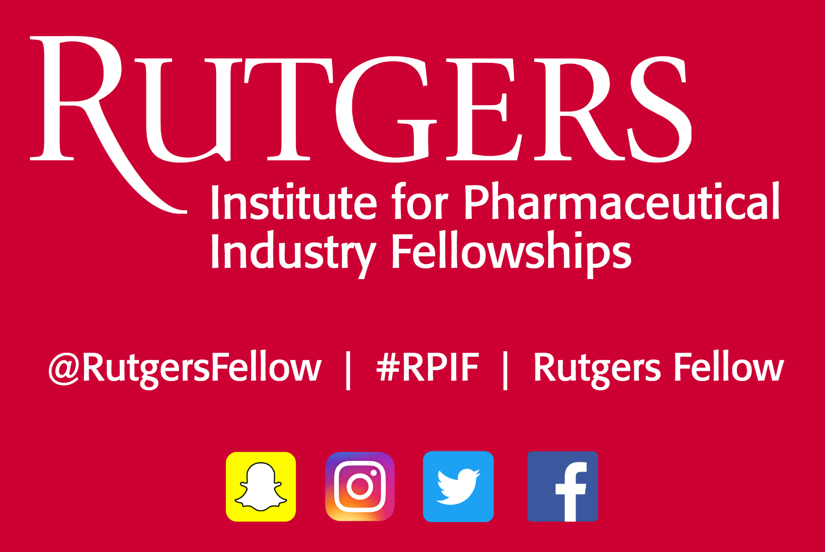


The RPIF Program fosters growth and development of future industry professionals through the following key program features:
- Training opportunities with leading pharmaceutical/biopharmaceutical companies
- Outstanding alumni hold prominent positions at more than 100 companies
- A strong network of fellows, alumni, preceptors and faculty
- A trusted and proven pathway to industry for pharmacists, since 1984
- An enhanced career path
- Rigorous academic and professional development opportunities
For more information visit http://pharmafellows.rutgers.edu and add us on social media! (handles below)



