**Pocket Lab Card Sale**

*Rho Chi Society – Alpha Omicron Chapter*

**What is it?**

Set of 10 lab cards with front and back filled with helpful information on topics including, but not limited to, normal levels for lab values (sample below), diabetes guidelines and treatment, common interactions, and so much more!

These lab cards fit nicely in your white coat pocket and are perfect for casework during practica, capstone cases, and as a quick reference while on rounds and rotations.

**How to get them:**

$10 dollars cash or check (made out to the University of Pittsburgh) to Annie McAndrew (P3), Jordan Serio (P3), Andrew Stehley (P2), or Keely Gambler (P2).

OR by Venmo to @Jordan-Serio

**Deadline:** Friday, April 13th, 2018

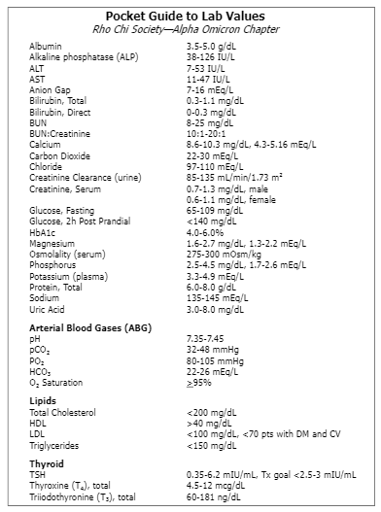

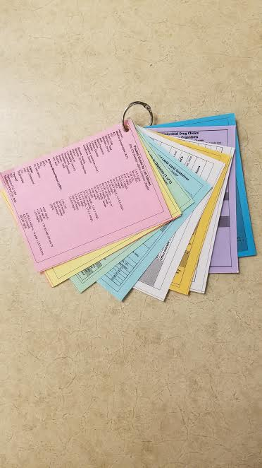

*Lab cards will be all white