**University of Pittsburgh**

**School of Pharmacy Clothing Sale**

Presented by Lambda Kappa Sigma

Dear Students and Parents,

It is time for the fall LKS, School of Pharmacy clothing sale. As one of our fundraisers, the sisters of Lambda Kappa Sigma provide you with the opportunity to purchase University of Pittsburgh School of Pharmacy merchandise.

In order to ensure that all clothing will be ready in time for the end of the semester, all order forms must be received **no later than Wednesday, October 25th.** All of the clothing is available in sizes small to 2XL and unisex, unless otherwise noted. In addition, the sweatshirts, quarter zips, polo shirts, and sweatpants are embroidered. Attached is an order form that can be given to any LKS sister or mailed to:

Alison Manjerovic

312 Main Blvd

Pittsburgh, PA 15237

Please include payment when placing your order—cash and checks will be accepted. **Make checks payable to Lambda Kappa Sigma**. Please do not mail cash. Unfortunately, we are unable to offer shipping to your home; students can pick up the items in the PCLC in the pharmacy school once the items arrive. If you have any questions, please contact either fundraising co-chair: Alison Manjerovic at amm370@pitt.edu or Katie Halza at kgh16@pitt.edu.

Thank you for your support,

The sisters of Lambda Kappa Sigma

**Disclaimer: The Pitt Shop prohibits returns/exchanges, as these are all custom items. Similar items are available in the store for comparing sizes, if necessary.

Logo designs: 1) t-shirts 2) sweatshirts 3) quarter zip/polo/sweatpants/baseball cap 4) blanket

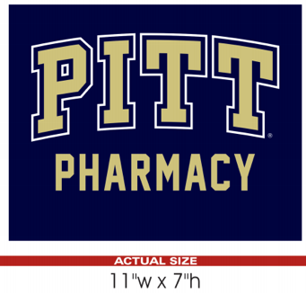  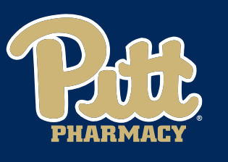 

1 2 3 4

School of Pharmacy Clothing Sale Order Form

Please submit **no later than Wednesday, October 25th**

Student Name:                                           _________________________________

Student Class: P1   P2   P3    P4

Phone Number:                    ______ __E-mail:                  _____________ _______

Total Amount Due:                                Please Select:  Cash             Check

|  |  |  |  |  |  |
| --- | --- | --- | --- | --- | --- |
| **Item** | **Price** | **Color (circle)** | **Size (circle)** | **Quantity** | **Total $** |
| Short-Sleeved T-Shirt | $15.00 | Navy | S M L XL  2XL 3XL |  | 3XL - add $1.50 |
| Long-Sleeved T-Shirt | $20.00 | Navy | S M L XL  2XL 3XL |  | 3XL - add $1.50 |
| Hooded Sweatshirt | $45.00 | Gray  Navy  White | S M L XL  2XL 3XL |  | 3XL - add $2 |
| Crew neck Sweatshirt | $40.00 | Gray  Navy  White | S M L XL  2XL 3XL |  | 3XL - add $2 |
| 1/4-zip Sweatshirt, collared with logo in upper left | $40.00 | Gray  Navy  White | **Men's OR Women's**  S M L XL  2XL |  |  |
| Golf Polo Shirt: “PITT Pharmacy” in upper left | $35.00 | Navy | **Men’s OR Women's**  Men: S -> 4XL  Women: XS -> 3XL |  | 3XL&4XL -add $4 |
| Sweatpants, elastic waist & non-elastic bottoms: logo on hip  (*limited availability) | $45.00 | Gray  Navy | S M L  XL 2XL |  |  |
| Fleece Blanket: logo in corner (*limited availability) | $35.00 | Navy | One size |  |  |
| Baseball Cap | $20.00 | Navy | One Size |  |  |
| TOTAL |  |  |  |  | $ |

*All items with limited availability are first come, first serve

*Sizes available for the sweatpants:

- Gray: 1 small, 3 medium, 4 large, 4 XL, 1 XXL

- Navy: 5 small, 4 medium, 0 large, 3 XL, 1 XXL