**SSHP Vaccine Project**

**About the Project:**

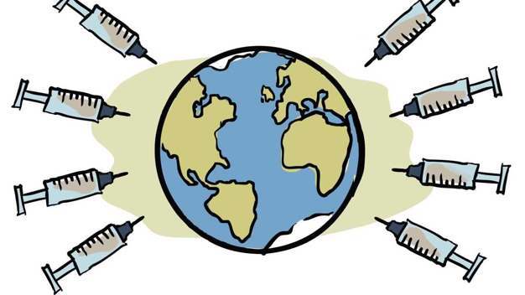Our mission is to educate the community on why vaccines are important and which they are eligible for, as well as providing resources for where to receive necessary vaccines. We are able to do this through presentations at events, specialized presentations for organizations seeking information, workshops, and more.

**Topics:**

* Travel Vaccines
* Routine Vaccines
* Flu shots
* Current Outbreaks (i.e. Zika)

**Upcoming:**

* Interest Meeting: August 31st at lunch or September 5th at lunch
* Pitt’s Study Abroad Fair: September 8th 10 am – 1 pm (William Pitt Union Lawn)
* CMU’s Study Abroad Fair: September 15th 11 am – 2:30 pm (Jared L. Cohon University Center)

If you are unable to attend an interest meeting or have any questions please reach out to Michelle Miller at [msm88@pitt.edu](mailto:msm88@pitt.edu) or Luke Jennings at [LTJ5@pitt.edu](mailto:LTJ5@pitt.edu) ! We look forward to hearing from you!