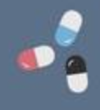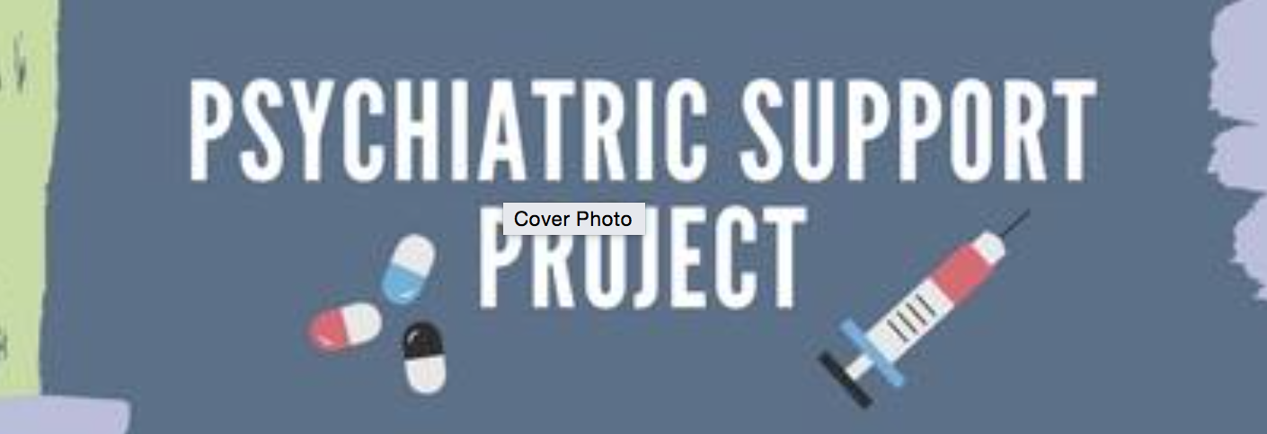

Our purpose is to increase awareness about vaccines and diabetes while serving as a supportive resource to this vulnerable population.

## ABOUT US

🙞 🙜

### SSHP

🙞 🙜

Students travel to Mercy Behavioral Health and Harbor light to educate patients struggling with mental illness and/or drug addiction about vaccinations, namely influenza and hepatitis C vaccine, diabetes, and general health habits.

# Opportunity

Psychiatric

Support

Project

* Increased experience with a unique population
* Opportunities to create your own contacts
* A chance to offer your own site and project to discuss you feel would benefit the group
* IPPE hours : (2-4 hours per semester)
* Poster making and presentation skills in small group
* Interest to become a project leader yourself!

Carly Gabriel

CTG12@pitt.edu

Miranda Steinkopf

MPS67@pitt.edu

## CONTACT US

# What the project gives you