**SciTech Week**

* Educate the public on overdosing
* All ages will be present
* Present poster
* Use interactive SimMan as a demonstration
* When: TBD
* Where: Carnegie Science Center

**Mr. Yuk**

* Great opportunity to work with younger kids in grades 1-3rd
* Teach the kids about household supplies & their toxicities
* Hands on activities
* Hand out for parents
* When: Select Monday & Wednesday afternoons between 4 and 6 pm
* Where: YMCA, Boys & Girls Clubs, & Elementary Schools

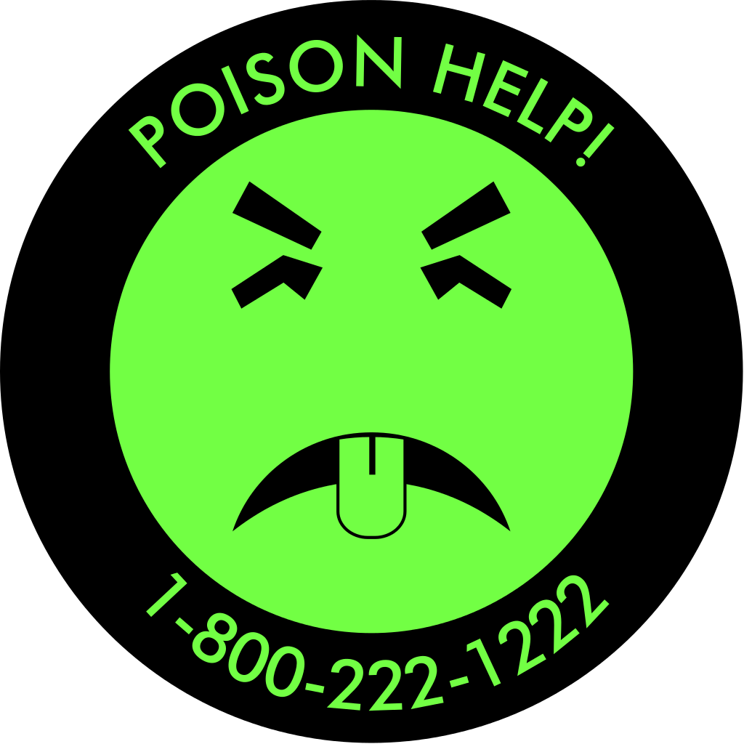

**Alcohol Poisoning**

* Educate freshman on what to do and when to get help for sick and intoxicated friends
* Present poster
* Quiz knowledge by playing a game of water-pong
* When: Mainly Sunday evenings & possible other days
* Where: Freshman dorms & other buildings on campus

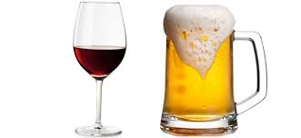

**SSHP**

**Poison Prevention Project**



Jordan Serio – P3

Kara Ioannou – P3

Kelly Jenniches – P2

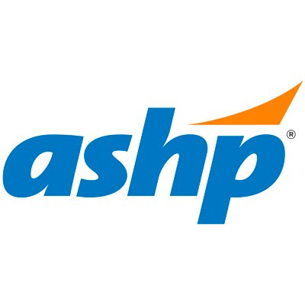

Feel free to contact us with any questions!

Email:

sshppoisonprevention@gmail.com

Jordan – jms456

Kara – kai25

Kelly – kaj60

We are looking forward to a fun and productive year! ☺

**About Our Project**

Our goal is to reach out to the community and educate as many people as we can about various aspects of poison prevention.

You will have the opportunity to learn more about our topics and give presentations on them throughout the semester.

All events are IPPE approved.

Our first information session will be held on **Thursday, September 14th at 12 pm.**

Room TBD